Thesis for Master’s Degree

Representational Power of Graph Neural Networks: A Novel Approach on Time-Series
그래프 신경망의 표현력: 시계열에 대한 새로운 접근

Hacı İsmail Aslan
Computer Engineering Major
Department of IT Convergence Engineering
Graduate School
Gachon University

Thesis for M.S. Degree
Supervised by Professor Chang Choi

Representational Power of Graph Neural Networks: A Novel Approach on Time-Series
그래프 신경망의 표현력: 시계열에 대한 새로운 접근

Submitted in Fulfillment of the Requirements for the Degree of IT Convergence Engineering
May, 2023
Hacı İsmail Aslan
Computer Engineering Major
Department of IT Convergence Engineering
Graduate School
Gachon University
This certifies that the master’s thesis of Hacı İsmail Aslan is approved
May, 2023

Committee Chairman (seal)

Committee Member (seal)

Committee Member (seal)

Committee Member (seal)

Committee Member (seal)

Abstract
The field of graph-based data analysis has recently gained attention due to the increasing popularity of non-tabular data formats. Examples of such data include social networks, data flow maps, citation influence graphs, and protein bindings. As the number of applications representing graph data increases, the representational power of these applications comes into question. Therefore, this thesis first evaluates the representational power of some of the main graph machine learning models. Second, it applies a novel method that utilizes Graph Neural Networks (GNN) for biometric authentication tasks, enabling GNNs to generalize time-series data.
The labeling of discrete communities in social networks is critical for analyzing graph networks, and several artificial intelligence approaches have been evaluated for partitioning vertices based on topological features. In this context, the "harmonic functions" method was found to be the most effective for classifying constituents of graph-shaped datasets, when it comes to supervised learning. Furthermore, this research in the first chapter, sheds light on the limitations of graph neural networks in comparison to non-neural network approaches, which are faster and computationally cost-effective. In the second chapter, this thesis mentions electrocardiogram (ECG) signals that have been widely used as a biometric authentication method in the field of cybersecurity. A novel method, the VisGIN model, which utilizes Graph Isomorphism Network Convolution (GINConv) for the convolutional layers and visibility graphs as input, has been proposed for ECG authentication. The second chapter shows that the VisGIN approach achieves high classification accuracy in grant-access decisions, making graph machine learning models applicable for time-series binary classification tasks, particularly in ECG authentication.

Contents
1. INTRODUCTION 1
1.1 Background 1
1.2 Research Motivation 2
1.3 Problem Statements 3
1.4 Main Contributions 4
1.5 Composition of the Thesis 5
2. BACKGROUND 6
2.1 Graph Neural Networks 6
2.1.1 Spatial Approaches 8
2.1.2 Spectral Approaches 10
2.2 Harmonic Functions 11
2.3 Visibility Graphs 12
2.4 Time-Series Data and Electrocardiogram (ECG) 13
3. EXPLORING GNNs ON EXTRACTING NODE EMBEDDINGS 16
3.1 Graph Data 16
3.2 Comparison of GNNs and Harmonic Functions 18
3.2.1 Graph Convolutional Networks (GCN) 18
3.2.2 Graph Attention Networks (GAT) 20
4. GNN FOR ECG BIOMETRIC AUTHENTICATION 22
4.1 Biometric Authentication with Machine Learning 22
4.1.1 Where Biometric Authentication Fails 23
4.1.2 ECG Excels in Biometric Authentication 25
4.1.3 Related Work 26
4.2 Proposed Method for Biometric Authentication 30
4.2.1 Preprocessing ECG Data 30
4.3 Proposed Method for Time-Series Classification with GNNs 33
4.3.1 Graph Isomorphism in Time-series 34
4.3.2 Graph Isomorphism Network 35
5. IMPLEMENTATION ENVIRONMENT, RESULTS AND DISCUSSION 36
5.1 Environment Details 36
5.2 Results for Node Classification 39
5.3 Results for Biometric Authentication with VisGIN 40
5.3.1 Effects of Baseline Wander Removal 42
5.3.2 Extending the Number of Pulses per Patient 44
6. CONCLUSION AND FUTURE DIRECTION 49
6.1 Conclusion 49
6.2 Prospective Future Direction 50
References 52
Acknowledgements 61
Publications from the Thesis 61

List of Tables
Table 1. Summary of datasets used for node classification. 18
Table 2. Hardware requirements for the study mentioned in chapter 3. 37
Table 3. Software requirements for the study mentioned in chapter 3. 37
Table 4. Hyperparameters for node classification task. 37
Table 5. Hardware requirements for the study mentioned in chapter 4. 38
Table 6. Required software packages for implementing chapter 4. 38
Table 7. Hyperparameters for training proposed VisGIN model. 38
Table 8. Test Accuracies for node classification. 40
Table 9. Comparison of the classification models depending on baseline correction application. 43
Table 10. Comparison of performance between VisGIN and baseline models. All values are presented in percentage. 46

List of Figures
Figure 1. A sample of ECG signal for 10 seconds, its filtered form, and applying baseline correction, respectively. 15
Figure 2. Zachary's Karate Dataset. 17
Figure 3. The false match and false non-match rates indicate the correlation between matching scores and class probabilities of impostor and genuine distributions. 24
Figure 4. The false match rate (FMR) and false non-match rate (FNMR) trade-off represents the balance between security and convenience. 24
Figure 5. The schematic representation illustrates the baseline method's overall scheme. In the "one-by-one personal authentication results" section, each figure corresponds to the output of a distinct model. 30
Figure 6. Data storage, filtering, and pulse segmentation. 31
Figure 7. The proposed VisGIN model. 33
Figure 8. Cosine similarity versus Manhattan distance. 45
Figure 9. ECG pulse signals of a selection of individuals. X-axis and y-axis denote sample numbers and magnitudes (mV), respectively. 47
Figure 10. Corresponding visibility graphs of the signals in Figure 9. 48

INTRODUCTION

1.1 Background
Social networks are becoming increasingly prevalent in the modern era, and the exchange of information in these networks can take various forms such as physical contact, messaging, collaboration, and emotional closeness. These networks can be represented as knowledge maps, which take the form of a graph structure [1]. Analyzing data in graph format is essential for gaining insights into social networks.
Data is typically represented in a tabular or non-Euclidean format to facilitate structured analysis [2]. In tabular format, data is organized as rows and columns, and there is no inherent relationship between samples. However, in real-world scenarios, samples are often interdependent and have connections to other samples across multiple topics. Graph networks are useful in such scenarios, as they can capture the relationships between samples and represent them with links. Later sections will delve into the mathematical foundations of graph networks.
Being graph specific, the research of GNNs on time-series is still a hot topic [3, 4]. The approach to the time series classification from the perspective of graph domain influenced this thesis. Thus, this thesis, first investigates the limits of graph machine learning models on its natural domain such as social networks, and then proposes a new scheme for biometric authentication using ECG signals and graph isomorphism networks.

1.2 Research Motivation
Biometric authentication has gained significant attention as a reliable and secure method for personal identification. Traditional biometric techniques, such as fingerprint and iris recognition, have been widely used in various applications. However, they have limitations when it comes to certain scenarios, such as individuals with compromised or inaccessible biometric features.
Electrocardiogram (ECG) signals have emerged as a promising alternative for biometric authentication. ECG signals are unique to individuals and exhibit distinctive patterns that can be utilized for identification purposes. The inherent advantages of ECG signals, such as their universality, non-invasiveness, and continuous availability, make them an appealing biometric modality.
Graph neural networks (GNNs) have shown remarkable success in various domains, including computer vision, natural language processing, and social network analysis. These models leverage the inherent graph structure of data to capture complex relationships and dependencies among elements. While GNNs have demonstrated impressive performance in several applications, their potential for time-series data, such as ECG signals, remains largely unexplored.
The motivation behind this research stems from the need to develop an effective and efficient biometric authentication system using ECG signals. By harnessing the power of GNNs, we aim to leverage the graph representation of ECG signals and exploit the temporal dependencies within the data to enhance authentication accuracy and robustness.
Through this research, we strive to bridge the gap between biometric authentication and graph neural networks, contributing to the advancement of both fields. The outcomes of this study have the potential to revolutionize biometric authentication systems and pave the way for more secure and reliable identification methods in diverse real-world applications.

1.3 Problem Statements
Variety of problems that exist to converge ECG biometric authentication and GNNs are listed below:
Problem statement 1: Representing time-series data as a graph is challenging because time variant signals do not form graphs, naturally.
Problem statement 2: As number of samples in the time-series signal increases, the size of the adjacency matrix that forms the structure of the graph increases in proportion to the square of the number of samples. Thus, applying GNNs on graph transformed time-series data is inefficient in terms of time and space complexity.
Problem statement 3: For smaller graphs, graph isomorphism is more likely to be an issue comparing to larger graphs. That results in the hardship of distinguishing distinct graphs.
Problem statement 4: The characteristics of ECG are up to vanish in the signal’s visibility graph. Some features like width, amplitude, and slope must remain in the graph somehow.

1.4 Main Contributions
Our work makes the following contributions:
(i) We demonstrated the utility of topological connections in graph-based machine learning. Specifically, we perform node classification tasks using three machine learning methods while solely leveraging the topological structures of the graph data, without considering any node features. This showcases the significance of topological information in achieving accurate classification results. (ii) We provided empirical evidence highlighting the effectiveness of harmonic functions compared to graph convolutional networks (GCN) and graph attention networks (GAT) in the context of homogeneous graphs without node and edge features. Our results underscore the superior performance of harmonic functions in capturing the underlying structural patterns of such graphs, offering valuable insights for graph-based learning on featureless data. (iii) We performed an extensive experimental evaluation on a wide range of commonly used baseline models for time-series binary classification tasks. Our results demonstrate significant improvements for most of the models considered. (iv) We introduced a novel pulse extraction algorithm that shares similarities with, but also incorporates distinct elements from, the traditional template-matching approach. This innovation enhances the accuracy of pulse extraction in our proposed methodology. (v) We presented VisGIN (Visibility Graph Neural Network), a unique model designed for graph-level classification of one-dimensional data in the context of biometric authentication. Our experimental results establish VisGIN as a state-of-the-art solution, highlighting the effectiveness of graph-based machine learning techniques in the field of time-series analysis.

1.5 Composition of the Thesis
This thesis is organized as follows: Chapter 2 introduces the necessary knowledge to start reading the study. It gives a brief introduction to GNNs, harmonic functions, visibility graphs and ECG data. Chapter 3 provides a comprehensive analysis of graph machine learning models and explains how these models work on graph data, particularly for social networks. Chapter 4 presents the main idea and application of this thesis. In chapter 4, readers can get an in-depth introduction to biometric authentication with machine learning. Furthermore, this chapter includes the main intuition of the thesis which is to apply visibility graph transformation on ECG data and utilize graph isomorphisms networks to distinguish signal ownership. Chapter 5 outlines the results of studies mentioned in chapters 3 & 4. Finally, chapter 6 concludes the thesis based on the findings and discusses the future directions.

BACKGROUND

2.1 Graph Neural Networks
Graph neural networks, or GNNs, have become a popular approach for processing graph-structured data, due to their ability to capture both the structural and attribute information of the nodes in the graph. GNNs typically consist of multiple layers, where each layer performs a message-passing operation on the graph to update the node representations based on their local neighborhood structure.
A GNN [5] is a neural network that can handle non-Euclidean data, making it a novel method for grid-wise graph inputs that show intercorrelations between samples and evaluate various tasks. GNNs are becoming increasingly popular and have been applied in various fields, such as molecular biology [6], network sociology [7], knowledge graphs [8], road traffic [9], natural language processing [10], and computer vision [11]. Recent developments in different versions of GNNs, including GCN, GraphSAGE [12], APPNP [13], SGC [14], GAT [15], and DGI [16], have led to the growth and dissemination of this area of neural networks. Among these variations, GCN and GAT are exemplary since one leads the convolutional approaches, while the other leads the attention-based mechanisms. In addition to variations of GNNs, other learning methods such as random walks, spectral graph theory applications, nearest neighbor approach, and harmonic functions [17] are notable. The latter is explained in the following sections of this thesis in depth.
The key feature of GNNs is their use of graph convolutional layers, which operate on the adjacency matrix and node feature matrix to aggregate information from neighboring nodes and update node representations. These layers use a learnable kernel to weigh the contributions of neighboring nodes, allowing for the propagation of information across the graph.
Another important aspect of GNNs is the use of graph pooling layers, which are used to down-sample the graph and reduce its complexity. Graph pooling is typically performed by selecting a subset of nodes and aggregating their features into a single node, which can then be used as a summary representation of the original subgraph.
At the end of the GNN, a graph-level representation is obtained, which is used for the final classification task. This output is typically passed through a fully connected layer followed by a softmax function to obtain a probability distribution over the possible classes. The use of graph-level representations allows GNNs to handle graphs of varying sizes and structures, making them useful for a wide range of applications, including social networks, biological networks, and knowledge graphs.
In recent years, GNNs have shown impressive performance on a variety of tasks, including node classification, link prediction, and graph classification. However, there are still many open research questions, including the scalability of GNNs to large graphs, the robustness of GNNs to noisy data, and the interpretability of GNNs, among others. Overall, GNNs represent a promising avenue for processing graph-structured data and are likely to play an increasingly important role in the field of machine learning in the years to come.
In the literature, there are various types of GNN layers. Hence, a short summary of the intuition behind this research field is given in sections 2.1.1 and 2.1.2.

2.1.1 Spatial Approaches
In a study by Duvenaud et al. in 2015 [18], they proposed a novel spatial methodology where they began by setting up the feature vector $f^{t}\left(v\right)$ for every node in the graph. The researchers subsequently computed feature embeddings for each node 𝑣 in every iteration using Equation 1, and $N$ denoted the set of neighboring nodes. Following this, a linear layer was employed before applying the activation function of softmax, as presented in Equation 2.
$$f^{t}\left(v\right)=f^{t-1}\left(v\right) +\sum_{w∈N\left(v\right)}{f^{t-1}\left(w\right)} (1)$$
$$f^{t}\left(v\right)=\text{softmax}\left(f^{t}\left(v\right)⋅H^{t}\right) \left(2\right)$$
In another study, Simonovsky and Komodakis introduced a GNN layer called "Edge-Conditioned Convolution" that utilized mean-field inference [19]. In their research, they derived the feature vector $f^{t}\left(v\right)$ for node $v$ at layer $t$ using Equation 3, where $W$ represents the parameter matrix and $l\left(w,v\right)$ is the label of the edge shared between nodes $w$ and $v$.
$$f^{t}\left(v\right)=1/\left|N\left(v\right)\right|\sum_{w∈N\left(v\right)}{F^{l}\left(l\left(w,v\right),W\left(l\right)\right)⋅f^{t-1}\left(w\right)+b^{l} } \left(3\right)$$
Similarly, Gilmer and colleagues conducted an investigation where they devised a message-passing structure, drawing on several of the GNN models discussed up to this point [20]. Their approach calculates the feature representation as shown in Equation 4. It is worth noting that $f_{\text{aggr}}^{W_{2}}$ sums the set of neighboring features, while $f_{\text{merge}}^{W_{1}}$ combines the node's embedding from the previous stage with the neighborhood embeddings in the final step.
$$f_{\text{merge}}^{W_{1}}\left(f^{t-1}\left(v\right),f_{\text{aggr}}^{W_{2}}\left(\{\{f^{t-1}\left(w\right) | w∈N\left(v\right)\}\}\right)\right) \left(4\right)$$
Section 4 provides an explanation that Xu and colleagues have raised doubts about the expressive power of GNN architectures [21]. They have demonstrated that the Weisfellar-Lehman algorithm limits its expressiveness. Essentially, they have established that no GNN model can differentiate between two non-isomorphic graphs. As a solution, they have introduced the Graph Isomorphism Network (GIN). In GIN, the calculation of the feature representation of node $v$ at layer $t$ is presented in Equation 5.
$$f^{t}\left(v\right)=MLP\left(\left(1+ϵ\right)⋅f^{t-1}\left(v\right)+\sum_{w∈N\left(v\right)}{f^{t-1}\left(w\right)}\right) \left(5\right)$$
The latter model has a huge impact on this thesis in terms of defining the VisGIN architecture that will be defined later.

2.1.2 Spectral Approaches
In spectral methodologies, when dealing with an undirected graph having $n$ nodes and an adjacency matrix $A$, the Laplacian matrix is obtained using Equation 6, and it is subjected to a convolution operation. It is noteworthy to mention that the diagonal matrix $D$ represents the degrees of the nodes. The factorization of $L$ is accomplished using Equation 7, where $U$ is the matrix containing eigenvectors and $Λ$ is the diagonal matrix.
$L=I-D^{-1/2}AD^{-1/2} \left(6\right)$
$$L=U Λ U^{⊤} \left(7\right)$$
Based on Equation 8, when $x$ is a graph, spectral methods are utilized to extend convolution to graphs. The convolution filter learned is labeled as $g$. The computation is clarified in Equation 9 and abbreviated in Equation 10 through the consideration of ${\text{g}}_{\text{θ}}=\text{diag}\left(U^{⊤\text{g}}\right)$.
$F\left(x\right)=U^{⊤}x \text{and} F^{-1}\left(\hat{x}\right)=Ux \left(8\right)$
$$x*\text{g}=U\left(U^{⊤}X⊙U^{⊤}g\right)=U⋅\text{diag}\left(U^{⊤}g\right)⋅U^{⊤}X \left(9\right)$$
$x*{\text{g}}_{\text{θ}}=U{\text{g}}_{\text{θ}}U^{⊤}X \left(10\right)$
In the context, ${\text{g}}_{\text{θ}}$ plays a pivotal role as the majority of spectral techniques fail to converge when incorporating the trained convolutional filter. Specifically, Bruna et al. (2013) proposed Spectral Convolutional Neural Networks, which adopt ${\text{g}}_{\text{θ}}$ as a collection of adjustable parameters denoted as $Θ_{i,j}^{t}$ [22]. As described in Equation 11, they present the formulation of the spectral Graph Neural Network layer they developed.
$$H_{j}^{t}=σ\left(\sum_{i=1}^{t}{U}Θ_{i,j}^{t}U^{⊤}H_{i}^{t-1}\right) \left(11\right)$$

Harmonic Functions
In mathematics, a harmonic function is a function that satisfies Laplace's equation, which describes the behavior of various physical phenomena such as heat conduction, fluid flow, and electrostatics. Essentially, a harmonic function is one that has no sources or sinks and is "smooth" or "uniform" across the domain it is defined on. In graph theory, harmonic functions are defined in terms of the Laplacian matrix, which is a matrix representation of the graph's connectivity structure. The Laplacian matrix is used to define a discrete Laplacian operator, which can be used to solve various problems on graphs, including classification tasks.
Harmonic functions are particularly useful for classification tasks in graph-based data analysis because they capture the underlying structure of the graph and can be used to infer information about the graph's vertices and edges. They have been used in a variety of applications, including image segmentation, social network analysis, and recommendation systems.
Zhe et al. propose a semi-supervised learning approach that employs Gaussian fields and harmonic functions, suitable for networks with a known topology [23]. The NetworkX library's API [24] is used to implement this classification technique on datasets in section 3. Harmonic functions are explained in Equation 12, where a function $h : V→R$ is deemed harmonic if the graph $G=\left(V,E\right)$ is also harmonic. The degree of the vertex is denoted as $d_{i}$. To gain a better understanding of the harmonic functions' classification, one can refer to He et al.'s work, which provides ample information on the subject [25].
$$h\left(V_{i}\right)=\frac{1}{d_{i}}\sum_{\left(V_{i},V_{j}\right)∈V}{h\left(V_{j}\right)} (12)$$
Overall, harmonic functions are a powerful tool for analyzing graphs and are an important technique in the field of machine learning and data science.

Visibility Graphs

A visibility graph is a topologic representation of discrete entities, where each entity is represented as a node, and an edge is established between two nodes if and only if the corresponding entities are mutually observable. The notion of visibility varies depending on the system or network being investigated. For instance, in the realm of image processing, visibility can be defined as the presence of an unobstructed path between two pixels. In this case, the visibility graph can be used to analyze the image's topological properties, such as the number of connected components, degree distribution, and clustering coefficient. In computer vision, visibility can be defined as the existence of a direct line of sight between two points in 3D space. In this instance, the visibility graph can be used to examine the scene's geometric characteristics, such as the angle distribution, point depth, and surface curvature. Visibility graphs have been shown to be beneficial in various fields of study, not only for the analysis of images, computer vision, and physics, but also for other areas such as time series analysis, signal processing, and even social networks. In this study, visibility graphs were employed as a transformation method for converting time series to graphs.
An edge is created between nodes $N_{i}$ and $N_{j}$ only when the following conditions are met. The maximum slope, ${slope}_{max}$ , is the slope of the line connecting the target node to its adjacent node on the right, $X$ represents the amplitude, and $t$ represents the signal's time step. Initially, the ${slope}_{max}$ for adjacent nodes is set to $-∞$ since these nodes must have an edge between them.
$$E_{ij}∈E,∃!E_{ij}⟺\frac{X\left[i\right]-X\left[j\right]}{t\left[i\right]-t\left[j\right]}>slope_{max} (13)$$
To construct edges in visibility graphs, Equation 13 is employed iteratively for the target node $N_{i}$ and all nodes to the right of the target node $N_{j}$ starting from the nearest neighbor to the farthest. In each iteration, ${slope}_{max}$ is updated to be the slope between the target node and the neighboring node.

Time-Series Data and Electrocardiogram (ECG)
Time-series data refers to data that is recorded and arranged in a chronological order. It is utilized in various fields, such as healthcare, finance, and economics. Electrocardiogram (ECG) is an example of time-series data that measures the heart's electrical activity over time.
In the medical field, ECG data is commonly used for the diagnosis and monitoring of various cardiac conditions. It provides vital information about the heart's function and helps medical practitioners make informed decisions about patient care.
ECG data is collected through an ECG machine that uses electrodes attached to the skin to detect the heart's electrical activity. The data obtained is a series of waveforms that illustrate the heart's electrical activity over time.
The analysis of ECG data requires specialized knowledge, training, and software tools. It can be used to identify abnormal heart activity and monitor changes in the heart's function over time.
Overall, ECG data is a valuable resource for healthcare providers as it provides insights into the heart's function and helps guide patient care.
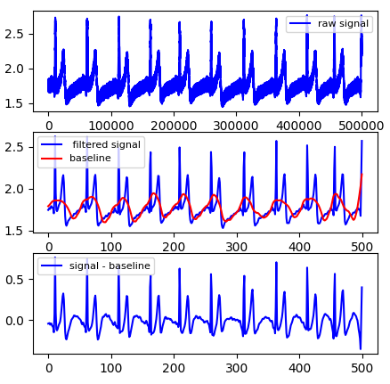
Figure 1. A sample of ECG signal for 10 seconds, its filtered form, and applying baseline correction, respectively.

3. EXPLORING GNNs ON EXTRACTING NODE EMBEDDINGS

Graph Data
To evaluate the throughput of research, it is crucial to carefully select appropriate data sets for processing with specific algorithms. As a result, researchers initially tested entire algorithms using a dataset known as "Zachary's Karate Club Dataset," which was created by Zachary et al. in 1977 [26]. The dataset is referred to as the "Karate Dataset" in this article and is selected based on its simplicity. It comprises 34 members of a local karate club, represented by vertices, and their social interactions, represented by edges. The club was later divided into two subgroups due to an internal dispute among officials, and the objective is to predict each student's final decision on which course to take. Figure 1 depicts the class instructors, represented by nodes 0 and 33.
A testbench dataset was obtained from a large European research institution and utilized in this study. The "Email-Eu-Core network" was chosen from the SNAP network repository [27] and analyzed by Bharali et al. [28]. The authors found that the network is a Small-World network that follows a power law regime and has an assortative mixing pattern on the degree of nodes. Furthermore, the network was found to be resistant to random failures but susceptible to targeted attacks. The average degree of the network, which is the number of edges compared to the number of nodes, was relatively high compared to other datasets analyzed in this study.
Figure 2. Zachary's Karate Dataset.
The internal mailing network represented in the graph network, referred to as the "Email Dataset," had some differences that made it a suitable candidate for node classification. Despite its challenging structure, this dataset was selected as one of the benchmark datasets for this study.
Two datasets, the "Cora" and "Pubmed" datasets, are noteworthy and were utilized in the research presented. Both datasets comprise scientific articles and their corresponding citation linkages. In both citation networks, nodes represent papers, while edges represent citations. The Spektral library [29] was used to obtain these datasets in the form of adjacency matrices. The citation networks are commonly utilized in graph theory to generalize classification results, which are discussed in the subsequent "Results" section. However, the Pubmed dataset presented a challenge due to its high average clustering coefficient. This coefficient refers to the likelihood of drawing a triangle with a node and its two distinct neighbors and can be interpreted as the fraction of closed triplets in the network graph.
 | Karate | Email | Cora | Pubmed
No. Nodes | 34 | 1.005 | 2.708 | 19.717
No. Edges | 78 | 25.571 | 5.429 | 44.338
No. Clusters | 2 | 42 | 7 | 3
No. Training Nodes | 2 | 804 | 2.166 | 5.000
Average Clustering Coefficient | 0.57 | 0.4 | 0.24 | 0.06
Average Degree | 4.59 | 25.44 | 3.9 | 4.5
Table 1. Summary of datasets used for node classification.

3.2 Comparison of GNNs and Harmonic Functions
To achieve the objectives of this research, two types of neural networks were utilized on the datasets and discussed in the subsequent subsections. Although there are numerous models that can be employed for classification tasks, this study focused on comparing harmonic functions with GCN and GAT. The aim was to establish a higher accuracy limit compared to the lower limit set by harmonic functions, thereby providing future neural network models with a benchmark for classification tasks.

3.2.1 Graph Convolutional Networks (GCN)
Graph Convolutional Networks (GCNs), introduced by Kipf et al. (2017) [30], represent an improvement over neural networks operating on graphs that were previously introduced by Gori et al. (2005) [31]. To facilitate comprehension, it is useful to present the mathematical foundations of GCNs. GCNs operate on an adjacency matrix A in the shape of $N × N$ and a feature matrix $H$ in the shape of $N × F$, where each vertex has a 2-D feature vector in the shape of $1 × F$. The fundamental propagation rule for a GCN is expressed by Equation 14.
$H^{'}=σ\left(AHW\right) \left(14\right)$
It should be noted that the weight matrix $W$ has dimensions $F×F^{'}$, $H^{'}$ denotes the newly generated node features, and $σ\left(⋅\right)$ denotes the non-linearity function. To simplify the sum of transformed features of all connected nodes for node $i$, Equation 15 was formulated to describe the correlation between node $i$'s features $h_{i}$ and the features of the nodes $h_{j}$ connected to node $i$. Please note that $V\left(i\right)$ represents the set of neighboring nodes of node $i$.
$$h_{i}=σ\left(\sum_{j∈V\left(i\right)}{W^{T}}h_{j}\right) \left(15\right)$$
Contrary to the earlier statement, the previous propagation rule based on the sum-pooling method is not always effective. This is due to the fact that the propagation rule presented in Equation 15 merely sums the feature vectors, which may cause the feature vectors to increase in scale with repeated applications. To address this issue, another update rule described by Equation 16 normalizes the adjacency matrix by multiplying it with the inverse of the diagonal degree matrix D. As a result, the newly updated node feature vector is represented by Equation 17.
$$H^{'}=σ\left(D^{-1}AHW\right) (16)$$
$$h_{i}^{'}=σ\left(\sum_{j∈V\left(i\right)}{\frac{1}{\left|V\left(i\right)\right|}}W^{T}h_{j}\right) \left(17\right)$$
The previous section outlined the propagation rules used in GCNs. Another important rule, known as symmetric normalization, can be derived from these equations and is shown in Equation 18. This rule involves multiplying the adjacency matrix by the square root of the inverse of the diagonal degree matrix, leading to a change in the node features as shown in Equation 19.
$$H^{'}=σ\left(D^{-1/2}AD^{-1/2}HW\right) (18)$$
$$h_{i}^{'}=σ\left(\sum_{j∈V\left(i\right)}{\frac{1}{\sqrt{\left|V\left(i\right)\right| \left|V\left(j\right)\right|}}}W^{T}h_{j}\right) (19)$$
In this section, GCN was implemented based on the theoretical foundations discussed in this section. However, the focus of this study was on working with the topological relationships of graph-structured data without considering any information related to nodes. Therefore, the features for each node were initially set to zero. Compared results are present in section 5 of this thesis.

3.2.2 Graph Attention Networks (GAT)
In their 2018 paper, Veličković et al. introduced Graph Attention Networks (GATs) as a novel approach that builds on the background of GCNs but incorporates specific "attention" mechanisms. While the mathematical foundations of GAT can be found in the original paper [15], it is important to highlight the unique extensions of GAT in the context of this study.
Unlike GCN, the coefficients in GAT are not fixed, as the coefficients are now dependent on the current input. This approach motivates the use of attention mechanisms in graph neural networks. With non-constant coefficients, the attention coefficient $α_{ij}$ for the receiver node $i$ and sender node $j$ is computed as shown in Equation 20.
$$α_{ij}=\frac{ exp(LeakyReLU(a[W^{T}h_{i}|| W^{T}h_{j}]))}{\sum_{k∈V\left(i\right)}^{n}{exp(LeakyReLU(a[W^{T}h_{i}|| W^{T}h_{k}]))}} (20)$$
$${h^{'}}_{i}=σ\left(\sum_{j∈V\left(i\right)}^{n}{α_{ij}W^{T}h_{j}}\right) \left(21\right)$$
To apply GAT in practice, a one-layered MLP denoted by $a$ is applied on concatenated messages $W^{T}h_{i}$ and $W^{T}h_{i}$ using the LeakyReLU activation function. Furthermore, GAT uses multi-head attention, meaning each layer has a fixed number of independent duplicates. The outputs from each duplicated layer are concatenated to produce the final feature vector. Equation 21 is used to normalize the attention coefficients and determine the corresponding features, which are then assigned as the final output features for each node.

4. GNN FOR ECG BIOMETRIC AUTHENTICATION

4.1 Biometric Authentication with Machine Learning
Security has become a significant concern as private information has become the center of the world. The development of various security schemes has led to potential solutions for ensuring the deployment of trustworthy applications. While there are several objectives for securing systems, including token authentication, password authentication, certificate-based authentication, and biometric authentication, the latter is widely considered the most reliable. Biometric authentication, or biometric identification, is a prevalent technique for user recognition compared to ownership-based and knowledge-based user recognition methods. However, both of these methods involve administrative costs and are vulnerable to forgery and identity theft.
Different biometric authentication methods are used for identifying individuals, such as unique physical or behavioral characteristics like face images [32], fingerprints [33], smartphone usage characteristics [34], or eye scans [35]. These methods are considered as reliable techniques for user identification and different studies have shown significant advancements in their accuracy, for instance, Knoche et al. [36] achieved state-of-the-art face recognition by employing a unique loss function and transformers and residual neural networks. These advancements have also influenced cryptography, as demonstrated by Kumar et al. [37] who proposed a real-life authentication scheme to improve the accuracy of multiserver authentication applications. Furthermore, recent studies have introduced lightweight authentication protocols, such as Minahil et al.'s [38] three-factor biometric authentication protocol for e-health that achieved higher efficiency and lower computation cost. Finally, the recent progress in biometric recognition for Internet of Things (IoT) applications was discussed by Zhang et al. [39], providing readers with a comprehensive overview of the topic.

4.1.1 Where Biometric Authentication Fails
Despite the widespread use of biometric authentication, the issue of vulnerability persists due to counterfeiting and fraud. Researchers such as Singh et al. [40] have highlighted the security and privacy concerns of biometric identification systems. Kumar et al.'s study was discussed regarding its resilience against adversarial attacks, while Inam ul Haq et al. [41] proposed a novel scheme to mitigate key compromise impersonation vulnerabilities. Uludag et al. [42] and Zhang et al. [43] examined spoof and attack cases in fingerprint and face recognition schemes respectively. These studies shed light on the challenges of achieving low false match rates in biometric authentication, as high false match results remain a significant drawback. Figure 1 illustrates the occurrence of false match and false non-match terms, impacting security and convenience. The trade-off between security and convenience is evident in Figure 2, represented by the receiver operating characteristic curve correlating false non-match rate and false match rate.
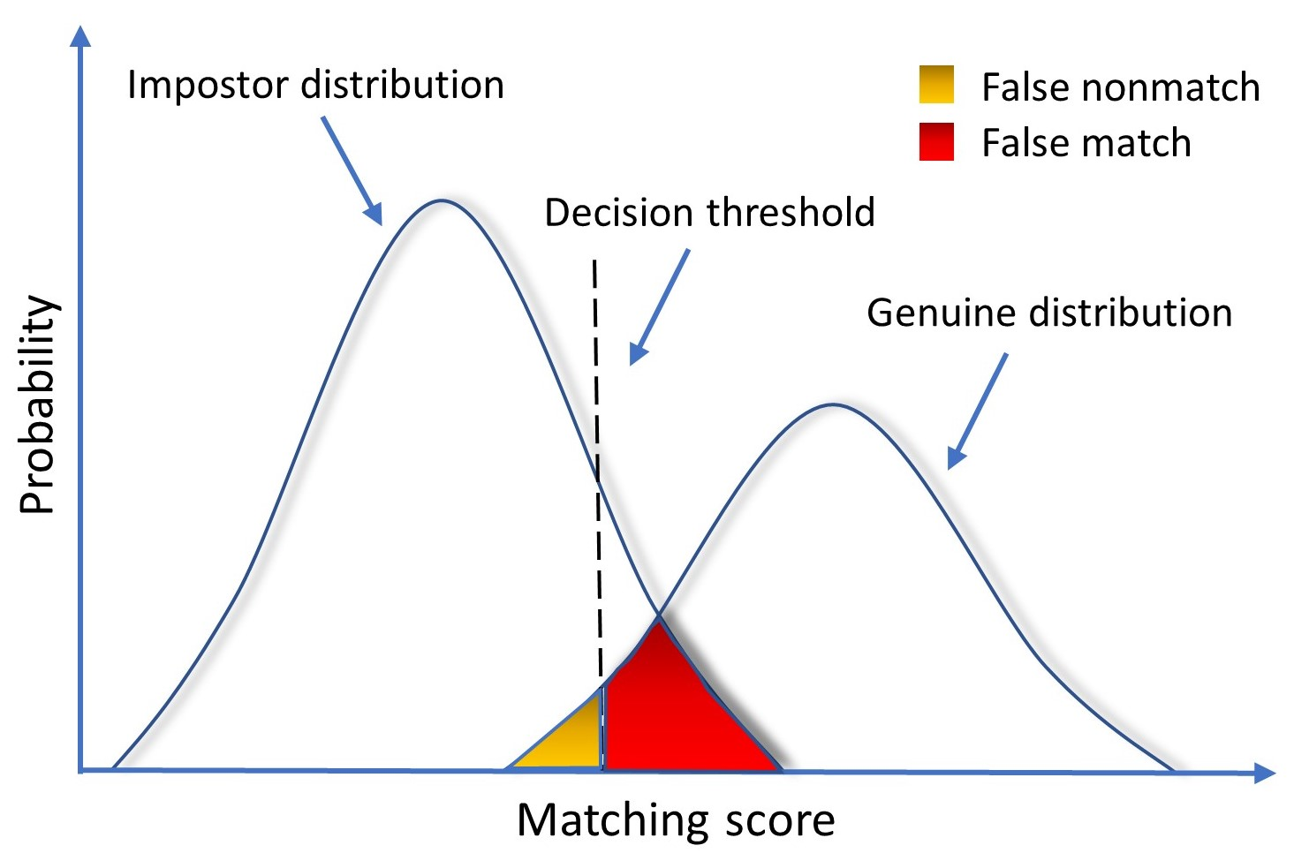
Figure 3. The false match and false non-match rates indicate the correlation between matching scores and class probabilities of impostor and genuine distributions.
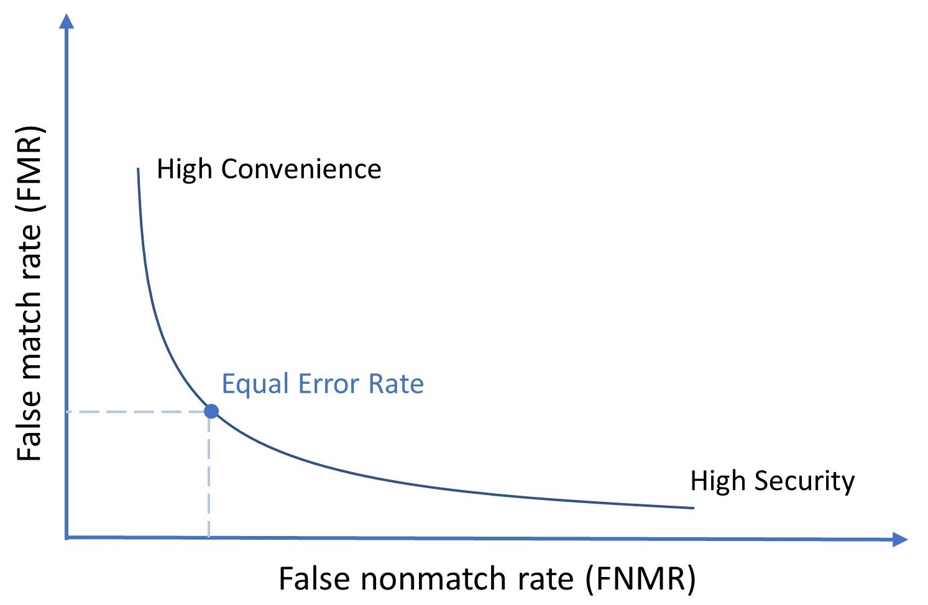
Figure 4. The false match rate (FMR) and false non-match rate (FNMR) trade-off represents the balance between security and convenience.

4.1.2 ECG Excels in Biometric Authentication
In this thesis, we delved into the realm of biometric identification practices with a specific focus on the utilization of electrocardiogram (ECG) signals. ECG, which measures the electrical activity of the heart, has emerged as a distinctive and promising input domain for biometric authentication.
One of the pioneering studies in the field was conducted by Biel et al. [44], who proposed an identification method using 12-lead ECG data. Their research demonstrated significant potential for ECG-based identification. However, it is important to note that the study had a limited number of samples, which limits the generalizability of their concept. Nevertheless, their findings laid the foundation for further exploration of ECG biometric recognition.
Building upon Biel et al.'s work, Odinaka et al. [45] conducted extensive research on ECG biometric recognition schemes. They investigated the effectiveness of earlier studies, particularly when the ECG data was obtained during the same session and captured subjects' rest or motion state. This line of research confirmed the viability of using ECG signals for biometric identification purposes, showcasing the potential of ECG as a reliable and unique biometric modality.
To provide a comprehensive analysis of ECG-based biometric authentication, Ingale et al. [46] published a detailed and comparative study on the subject. Their work not only synthesized the theoretical background of ECG biometrics but also shed light on recent advancements in the field. Their findings served as an important reference point for our own research, inspiring us to further explore the possibilities and challenges of ECG-based biometric identification.
In conclusion, the early studies by Biel et al. and subsequent research by Odinaka et al. and Ingale et al. have collectively contributed to the growing body of knowledge on ECG biometric authentication. These studies have highlighted the potential of ECG as a unique and reliable biometric modality, opening up new avenues for secure and convenient identification. By building upon these foundational works, we aim to further advance the field of ECG-based biometric identification and explore its practical applications in various domains.

4.1.3 Related Work
The utilization of ECG as a biometric modality has been explored since the early 2000s, demonstrating its potential in reliable identification.
The pioneering work by Biel et al. showcased impressive results in authentication using 12-lead ECG, highlighting the possibility of individual identification based on features extracted from a single lead. Inspired by this breakthrough, Shen et al. [47] conducted identity verification research using data streams from a single lead ECG device, incorporating a template-matching approach in the preprocessing stage. Their findings significantly influenced subsequent studies in the field.
Moving forward, Chan et al. [48] adopted a different approach by utilizing raw features of the ECG signals for biometric authentication. Their focus on extracting and analyzing the inherent characteristics of the ECG waveform contributed to the development of alternative methods.
In a distinct approach, Plataniotis et al. [49] introduced non-fiducial features in their study, incorporating additional attributes beyond traditional fiducial points. This novel perspective enhanced the richness of information used for ECG-based authentication.
With the emergence of data-centric strategies, researchers have turned their attention to data transformations to enhance the distinguishability of inputs. Among these methods, one of the earliest and influential techniques is piecewise linear regression (PLR), which is commonly employed in the feature extraction process [50, 51].
Feature extraction in ECG biometrics can be categorized into two branches: handcrafted and non-handcrafted. Fiducial features, along with PLR and autocorrelation [52, 53], fall under the handcrafted approach. While fiducial features may not enjoy the same popularity as other methods currently, they have been successfully utilized in combination with a classification algorithm like support vector machine (SVM), leading to noteworthy studies [54, 55].
In addition to fiducial features, handcrafted features can be obtained using techniques such as discrete cosine transform [56] and wavelet transform [57, 58], specifically designed for ECG biometric authentication. The field of handcrafted feature extraction offers diverse approaches. For instance, Kim et al. [59] explored the application of Shannon entropy to transform raw ECG data into an evaluatable form using decision trees. However, their experiments lacked high accuracy, and important metrics such as false match rate (FMR) and false non-match rate (FNMR) were not provided.
In a distinctive research endeavor, Li et al. proposed the utilization of graph regularization non-negative matrix factorization and sparse representations for ECG biometrics, presenting an innovative approach that sets it apart from other studies [60].
In addition to data-centric methodologies, model-centric approaches have also gained traction in the field of biometric authentication. Multilayer perceptron and convolutional neural networks (CNN) have been prominent focuses of research in recent years [61, 62]. CNN, in particular, has seen numerous variations and models proposed for individual authentication. Hong et al. introduced a CNN variant called Inception and conducted experiments using real and synthesized ECGs to demonstrate the effectiveness of their approach [63].
Another CNN-based model, Cascaded CNN, utilized two separate CNNs—one for feature extraction and the other for prediction [64]. Chu et al. adopted a similar technique , employing convolution layers for feature extraction and combining them with support vector machines (SVM) for matching [65].
Model-centric methods also involve the utilization of long-short term memory (LSTM) and recurrent units. For instance, Salloum et al. employed LSTM and recurrent neural networks (RNN) without any feature crafting method, achieving notable results with raw ECG data [66]. Yildirim [67] achieved high accuracies for cardiac arrhythmia detection tasks by utilizing LSTM and RNN, on many public datasets . Similarly, Lynn et al. combined LSTM and CNN in a non-fiducial manner, showing promising results but not surpassing the state-of-the-art benchmarks [68].
Recently, AlDuwaile et al. proposed a novel approach that combined CNN with entropy enhancement to achieve their objectives [69]. They employed a segmentation technique where they filtered signals around R-points (peaks in an ECG signal) with a time margin. In a similar vein, Jyotishi utilized a template-matching algorithm for segmentation [70]. Another innovative model, developed by Allam et al., incorporated a hybrid architecture that consisted of parallel concatenation of CNN and LSTM [71].
Additionally, Lee et al. conducted a study on the CU-ECG dataset, focusing on personal identification tasks [72]. They employed an ensemble model that combined a one-dimensional LSTM with a two-dimensional CNN. It is worth noting that our research shares a common dataset with Lee’s study. The aforementioned CU-ECG dataset is first introduced by Choi et al. in their research which implements a machine learning algorithm based on 2D features of the ECG spectogram [73].
In the subsequent sections of this paper, we will analyze the points of differentiation between our work and the aforementioned papers, specifically in terms of segmentation and classification methodologies.

4.2 Proposed Method for Biometric Authentication
This section compares the VisGIN model against other widely employed models in the field. Figure 5 provides a visual overview of the proposed method. Within this framework, there is a specific block dedicated to training baseline models on ECG pulses.
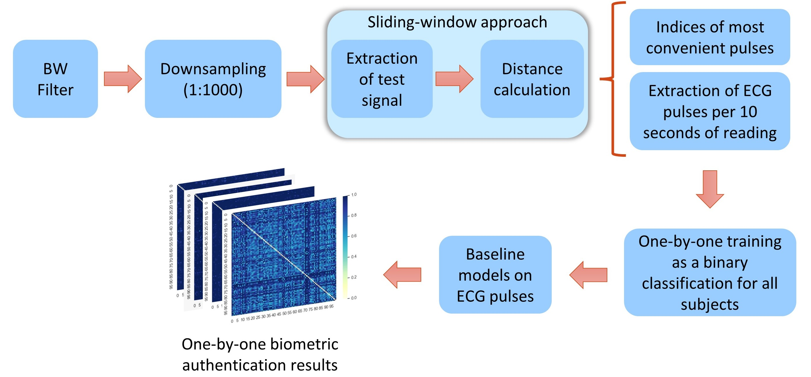
Figure 5. The schematic representation illustrates the baseline method's overall scheme. In the "one-by-one personal authentication results" section, each figure corresponds to the output of a distinct model.

4.2.1 Preprocessing ECG Data
Filtering of the ECG signal is necessary due to the potential influence of environmental conditions on the signal. While the hardware filters in the signal recorder minimize the impact of noise on the observed ECG signal, the presence of baseline noise remains a significant concern that needs to be addressed. In order to assess the effect of baseline wander on learning models, we have dedicated the experiments section to investigate the potential improvements achieved through baseline wander removal. As it will be shown in the section 5, baseline wander removal found out to be ineffective, according to our ablation study.
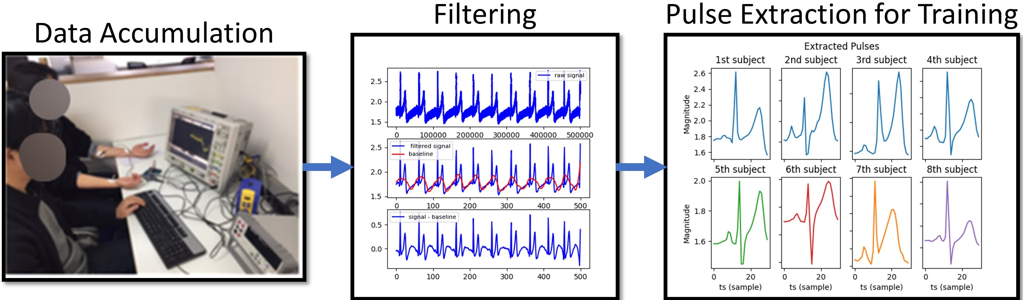
Figure 6. Data storage, filtering, and pulse segmentation.
The data processing aspect of this study is outlined in Figure 6. In the initial stage, the CU-ECG dataset was curated by collecting ECG records from 100 subjects, with each subject's measurements lasting for 600 seconds. These ECG records were then divided into batches of 10 seconds, resulting in a dataset consisting of 60 samples per patient. Subsequently, the raw one-dimensional ECG data underwent processing to filter out low-frequency components using a Butterworth filter. To accommodate the high hardware sampling rate of 50,000 Hz, the signals were downsampled to 50 Hz using software. We chose a downsampling rate of 1:1000 to reduce the training time and cost for the authentication mechanism.
The objective of “Pulse Extraction for Training” step is to represent each 10-second record with a single heart pulse, aiming to expedite training and reduce memory requirements. This approach is grounded in the periodic nature of ECG signals, where the same pattern repeats throughout the recording. By representing a sample with a single pulse, it becomes more convenient for machine learning models to train on these pulses.
The pulse extraction process is outlined in Algorithm 1, which utilizes a one-dimensional distance check. In each iteration, a generic PQRST segment of an ECG signal is chosen as a kernel, and its similarity or distance to the windowed portion of the input signal is calculated. Our approach stands out because other pulse segmentation methods fail to accurately extract exact PQRST segments. In contrast, our pulse extraction method generates a signal-specific representation, enabling learning models to deliver the desired performance.
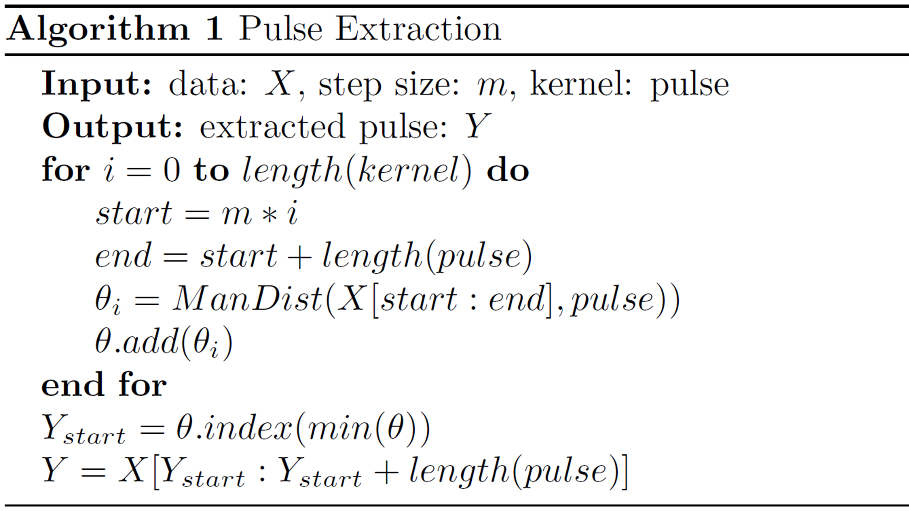
The choice of kernel size in our approach is informed by previous research [46], which indicates that the duration of an ECG pulse is typically around 0.6 seconds, on average. Considering the downsampled data at 50 Hz, a pulse comprises approximately 30 sample points, thus the kernel size is set to 30 samples. This design choice ensures consistency with prior findings and facilitates effective pulse extraction.

4.3 Proposed Method for Time-Series Classification with GNNs
As explained in the background section, Equation 13 is utilized to construct a visibility graph. These graphs encapsulate all the information present in a time series data, with each node attribute representing the amplitude of a sample at a specific time. By incorporating a graph structure, visibility graphs enhance the comprehension of information conveyed by one-dimensional signals. Building upon these unique characteristics of visibility graphs, the VisGIN model draws inspiration from their combination with the graph classification capabilities offered by Graph Neural Networks (GNNs). This integration allows for leveraging the strengths of both visibility graphs and GNNs in the VisGIN model.
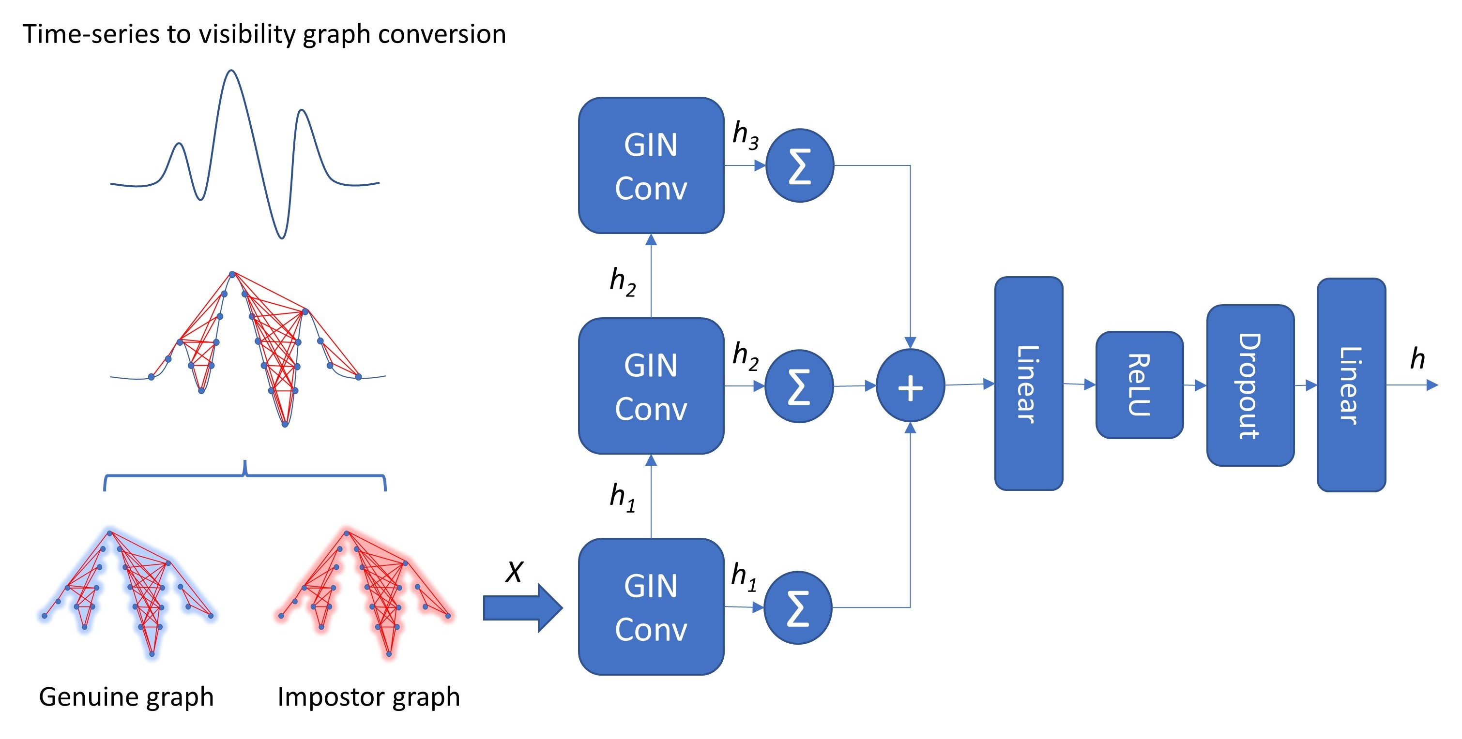
Figure 7. The proposed VisGIN model.

Specifically, in this study, the time-series signal was treated as a natural visibility graph $G\left(N,E\right)$. To construct the natural visibility graph for each graph in the dataset, a set of points $P=\{p_{1},p_{2},…,p_{30}\}$ is considered, and the following process is followed:
- Every individual point, denoted as $p_{i}$ in the set $P$, is correspondingly represented as a node $N_{i}$ within the set of nodes $N=\{N_{1},N_{2},…,N_{30}\}$.
- The feature vector $X$ for each node $N_{i}$ comprises four attributes. $X_{1}$ represents the amplitude of the associated sample point, while $X_{2}$, $X_{3}$, and $X_{4}$ correspond to the slopes between $p_{i}$ and $p_{\left(i+1\right)}$, $p_{i}$ and $p_{\left(i+2\right)}$, and $p_{i}$ and $p_{\left(i+3\right)}$, respectively.
- $p_{i}$ and $p_{j}$ are distinct points in $P$.
- The line segment that connects $p_{i}$ and $p_{j}$ does not intersect any other points in the set $P$.
- The graph $G$ is an undirected graph.

4.3.1 Graph Isomorphism in Time-series
The conversion process from one-dimensional signals to graphs presents a significant challenge related to the distinguishing of two distinct signals, known as graph isomorphism. Graph isomorphism is a fundamental aspect of differentiating graphs from one another. In this paper, we propose an approach that addresses this issue by employing a fixed number of nodes per graph (N = 30), which simplifies the structural complexity of the graphs while still considering the isomorphism challenge.
For two visibility graphs to be isomorphic, they must exhibit the same degree distribution. The degree distribution of a graph refers to the probability distribution of the degrees of all nodes within the graph. In other words, two graphs $G$ and $H$ are considered isomorphic $G≅H$ if there exists a structure-preserving bijection $f: N_{G}→N_{H}$, where the vertex function $f$ preserves adjacency.

4.3.2 Graph Isomorphism Network
To address the challenge of isomorphism, VisGIN incorporates a Graph Isomorphism Network (GIN) [21] as its underlying architecture. GIN enhances the expressive capacity of Graph Neural Networks (GNNs) by extending the Weisfeiler-Lehman (WL) test, which is capable of distinguishing non-isomorphic graphs when there are identical connections but node permutations. Therefore, the aggregator component of GIN was specifically designed to match the effectiveness of the WL test.
$$h_{i}=MLP\left(\left(1+ϵ\right)⋅x_{i}+\sum_{j∈N_{i}}^{N}{h_{i}^{0}}\right) (22)$$
In GIN, the aggregator generates distinct node embeddings for non-isomorphic graphs by utilizing two injective functions that are learned through a Multilayer Perceptron (MLP). Equation 22 describes the calculation of the hidden vector for a given node i, where ε represents the importance of the target node relative to its neighbors, and x denotes the feature representation of the node.
$$h_{G} = \sum_{i=0}^{N}{h_{i}^{0}} || … || \sum_{i=0}^{N}{h_{i}^{k}} (23)$$
In order to obtain the graph-level representation h₆ from the final node embeddings $h_{i}$, commonly used operators include mean ($h_{G}=\sum_{i=0}^{N}{h_{i}/N}$), sum ($h_{G}=\sum_{i=0}^{N}{h_{i}}$), and max ($h_{G}=max_{i=0}^{N}\left(h_{i}\right)$). However, the authors of GIN have highlighted the importance of preserving embeddings from previous layers to ensure proper consideration of structural information. They have also noted that the sum operator tends to be more expressive than the mean and max operators. Therefore, Equation 23 represents the global pooling approach used in GIN to address these considerations.

5. IMPLEMENTATION ENVIRONMENT, RESULTS AND DISCUSSION

5.1 Environment Details
Since this thesis comprises 2 major implementations, there are 2 distinct environmental setups to be explained. For the study outlined in chapter 3, Table 2, 3 & 4 represent the settings in general. Similarly, Table 5, 6 & 7 contains the general settings of the utilized environment in terms of hardware, software, and hyper-parameters, respectively.

CPU | Intel Xeon CPU @2.20 GHz
Memory | 35 GB
GPU | NVIDIA Tesla T4
OS | Ubuntu 18.04.6 LTS
Table 2. Hardware requirements for the study mentioned in chapter 3.
Programming | Python | 3.10.11
Virtual Environment | Pip | 23.1.2
Machine Learning | Jaxlib  Jax  Haiku  Optax | 0.3.2+cuda11.cudnn805  0.3.4  0.0.6  0.1.1
Data Visualization | matplotlib | 3.5.1
Data Transformation | Jraph | 0.0.2.dev0
Others | Numpy  NetworkX | 1.21.5  2.6.1
Table 3. Software requirements for the study mentioned in chapter 3.
Loss Function | Negative log-likelihood
Optimizer | Adam
Learning Rate | 0.01
Hidden Neuron Size | {64, 32}
Table 4. Hyperparameters for node classification task.

CPU | Intel Core i9-10980XE CPU @ 3.00GHz
Memory | 128 GB
GPU | NVIDIA RTX A5000
OS | Windows Server 2022 Standard (21H2)
Table 5. Hardware requirements for the study mentioned in chapter 4.
Programming | Python | 3.9.12
Virtual Environment | Pip | 21.2.4
Machine Learning | Fastai  Tsai  Torch  Torch-geometric | 2.7.9  0.3.1  py3.9_cuda11.3_cudnn8_0  2.1.0.post1
Data Visualization | Matplotlib  Seaborn | 3.5.1  0.11.2
Data Transformation | Ts2vg  Pandas  Scipy.signal | 1.0.0  1.4.2  1.7.3
Others | Numpy  NetworkX | 1.21.5  2.7.1
Table 6. Required software packages for implementing chapter 4.
Loss Function | Cross-entropy loss
Optimizer | AdamW
Learning Rate | 0.001
Hidden Neuron Size | {32, 32, 32}
Table 7. Hyperparameters for training proposed VisGIN model.

5.2 Results for Node Classification
To assess the mean accuracy levels, the average of results from 10 experiments was computed in addition to calculating the standard deviation. In all cases except for Pubmed-GCN and Pubmed-GAT, the train-to-test ratio was set at 0.8. However, for the Pubmed dataset, an out-of-memory error occurred due to the large number of processed nodes during training. To mitigate this issue, the Pubmed dataset was trained using 5000 vertices, which represents approximately 25% of the entire network.
$$Test Accuracy=\frac{ACC-\left(Training Samples Ratio\%\right)}{1-\left(Training Samples Ratio\%\right)} (24)$$
Understanding the tables in this section requires knowledge of the train-test split method employed in this study. The test accuracy measurement relies on the semi-supervised learning training backbone, which involves maximizing the negative log-likelihood of known node assignments. Here, the "known node assignments" refer to the train data, and consequently, an analogy between unlabeled data and test data can be established. Thus, when the model is provided with a certain number of samples with known ground-truth labels, the entire graph is considered as a single set that encompasses both test and train data. The accuracy for this combined set is recorded in Table 8 and referred to as ACC. However, it's important to note that the reported accuracy includes both train and test accuracy. To evaluate the test accuracy specifically for unlabeled data, a fraction of the train-to-test ratio is used, assuming a training accuracy of 100%, as described in Equation 24.
 | GCN | GAT | Harmonic
Karate | 100% | 100% | 100%
Email | 72.1 ± 0.52% | 67.95 ± 0.47% | 70.7 ± 0.68%
Cora | 81.45 ± 0.3% | 83.05 ± 0.29% | 86.35 ± 0.23%
Pubmed | 80.39 ± 0.26% | 80.73 ± 0.24% | 82.35 ± 0.07%
Table 8. Test Accuracies for node classification.
In terms of mean accuracy levels, it was observed that harmonic functions performed slightly better than other methods for node classification tasks on the Cora and Pubmed datasets. Additionally, the standard deviation was found to be smaller compared to the other datasets, indicating that harmonic functions exhibit greater robustness against variations in training samples. The decrease in standard deviation with an increase in the number of samples aligns with theoretical expectations.
However, the mean accuracy levels cannot be solely attributed to the number of samples, as they depend on the intrinsic characteristics of each graph. While the number of samples is a contributing factor, it is not the most critical one. In the context of graph-structured data, the heterogeneity issue emerges as a key factor that affects performance.

5.3 Results for Biometric Authentication with VisGIN
In this section, we assess the classification capabilities of the proposed VisGIN model. Evaluating accuracy metrics for an authentication scheme presents a significant challenge as it relies on defining the classification problem. To address this, we approach the evaluation phase of our study by treating authentication as a binary classification problem, aiming to distinguish between genuine and impostor signals. Consequently, data imbalance becomes a concern for an ML-based authentication scheme.
To overcome this challenge, we trained all possible binary matches between patients (a total of 4950 matches) in the dataset. We recorded performance metrics for each match and calculated their averages to showcase the overall performance of the model. The deviation in accuracy values presented in Table 10 represents the standard deviations of test accuracies across all possible authentication matches. We refer to the training process for the binary classification of each possible match in the dataset as "one-by-one biometric authentication," as depicted in Figure 5. The final results were obtained by averaging all classification performance metrics, providing a comprehensive assessment of the model's performance.
For experimentation with the VisGIN model, we utilized three layers with specific configurations. The batch size was set to 32, the learning rate was ${10}^{-3}$, the number of epochs was 500, the data splitting ratio was 0.2, the dropout rate was 0.5, and the optimizer used was AdamW. As we treated the authentication scheme as a binary classification task in machine learning, the cross-entropy loss function was employed for loss calculation.
About the dataset: The dataset used in our study was the CU-ECG dataset, comprising the ECG records of 100 subjects from the Chosun University IT Department. As mentioned in Section 4.2.1, each record was sampled at a rate of 50,000 Hz and had a duration of 10 seconds. Within the dataset, there were 60 records per subject, resulting in a total of 600 seconds of ECG recordings per subject. It is important to note that all observations were conducted under consistent environmental conditions, with the subjects seated in chairs.
Benchmarks: We conducted a comparative analysis of our VisGIN model against several benchmark models, including LSTM (Long Short-Term Memory) [74], a three-layered MLP (Multi-Layer Perceptron), TCN (Temporal Convolutional Network), mWDN (multilevel Wavelet Decomposition Network) [75], XCM (Explainable Convolutional Neural Network for Multivariate Time Series Classification) [76] , FCN (Fully Convolutional Network) [77], LSTM-FCN (LSTM-FCN Fusion) [78], MLSTM-FCN (Multivariate LSTM-FCN) [79], and InceptionTime [80]. These benchmark models were obtained from the tsai library [81] and implemented in Python.
Metrics: Consistent with the information provided in section 4.1.1, we employed several metrics to assess the performance of the models, including accuracy (ACC), False Negative Match Rate (FNMR), and False Match Rate (FMR). The Equal Error Rate (EER) metric was not included in the evaluation since the machine learning models consistently achieved FNMR and FMR values that converged to the same point, which is equivalent to the EER.

5.3.1 Effects of Baseline Wander Removal
Baseline wander refers to the gradual shift in the ECG signal's baseline level over time, posing a challenge in ECG signal processing. This phenomenon can be caused by various factors such as electrode motion, electrode impedance, cardiac arrhythmias, power line interference, and movement. As mentioned in section 4.2.1, the ECG signal contains baseline wander that needs to be addressed for visualization and analysis purposes. However, we decided to investigate the impact of baseline correction through experiments. To do so, we adopted the techniques proposed by Sargolzaei et al. [82]. We measured the performance of both baseline models and the VisGIN model, and the results in Table 9 demonstrated that applying baseline correction to the dataset was unnecessary as it did not improve the performance of most models. In fact, for many models, performance even decreased after baseline correction.
Model | Not Applied (%) | Applied (%)
LSTM | 92.98 ± 10.1% | 94.78 ± 8.2%
MLP | 97.15 ± 4.1% | 98.68 ± 2.8%
TCN | 97.29 ± 4.6% | 98.23 ± 3.6%
mWDN | 98.88 ± 2.4% | 99.03 ± 2.2%
XCM | 99.08 ± 2.2% | 99.04 ± 2.2%
FCN | 99.23 ± 1.9% | 99.26 ± 1.9%
LSTM-FCN | 99.24 ± 1.9% | 99.24 ± 1.9%
MLSTM-FCN | 99.27 ± 1.9% | 99.25 ± 1.9%
InceptionTime | 99.36 ± 1.8% | 99.30 ± 1.9%
VisGIN (Proposed) | 99.54 ± 1.5% | 99.55 ± 1.5%
Table 9. Comparison of the classification models depending on baseline correction application.
Based on the outcomes of training with baseline-corrected ECG data, we determined that the subsequent experiments should focus on training the data without baseline correction during the preprocessing stage. This decision was crucial since training each model could be time-consuming, particularly when training the models with an increasing number of pulses per patient, as we will elaborate on in the next section.

5.3.2 Extending the Number of Pulses per Patient
In this section, we conducted extensive experiments to evaluate the performance of our proposed VisGIN model compared to several baseline models. Specifically, we trained all models using three different settings, each involving a different number of pulses to represent a 10-second ECG sample. The first setting used a single pulse, the second setting used two pulses, and the third setting used three pulses. This experimental design allowed us to examine the influence of the number of pulses on the performance of both our proposed model and the baseline models.
To achieve this, Algorithm 1 is updated to sort the similarity/distance scores ($θ_{i}$), select the top $M$ maximum similarities/minimum distances, and retrieve the original indices of these scores in the ECG data to obtain $Y⊃Y_{1},Y_{2},…Y_{M}$. During this process, we ensured that the system avoided overlapping in the extracted pulses, ensuring that no samples were included in multiple pulses. Additionally, to determine the most suitable similarity metric for the algorithm, we conducted experiments using both Manhattan distance and cosine similarity, as illustrated in Figure 8.
The performance results of the baseline models and VisGIN are presented in Table 10. As observed, the performance of all models improves as $M$ increases. As we expected, the proposed VisGIN model demonstrated the effectiveness of graph-based machine learning models in the time-series domain.
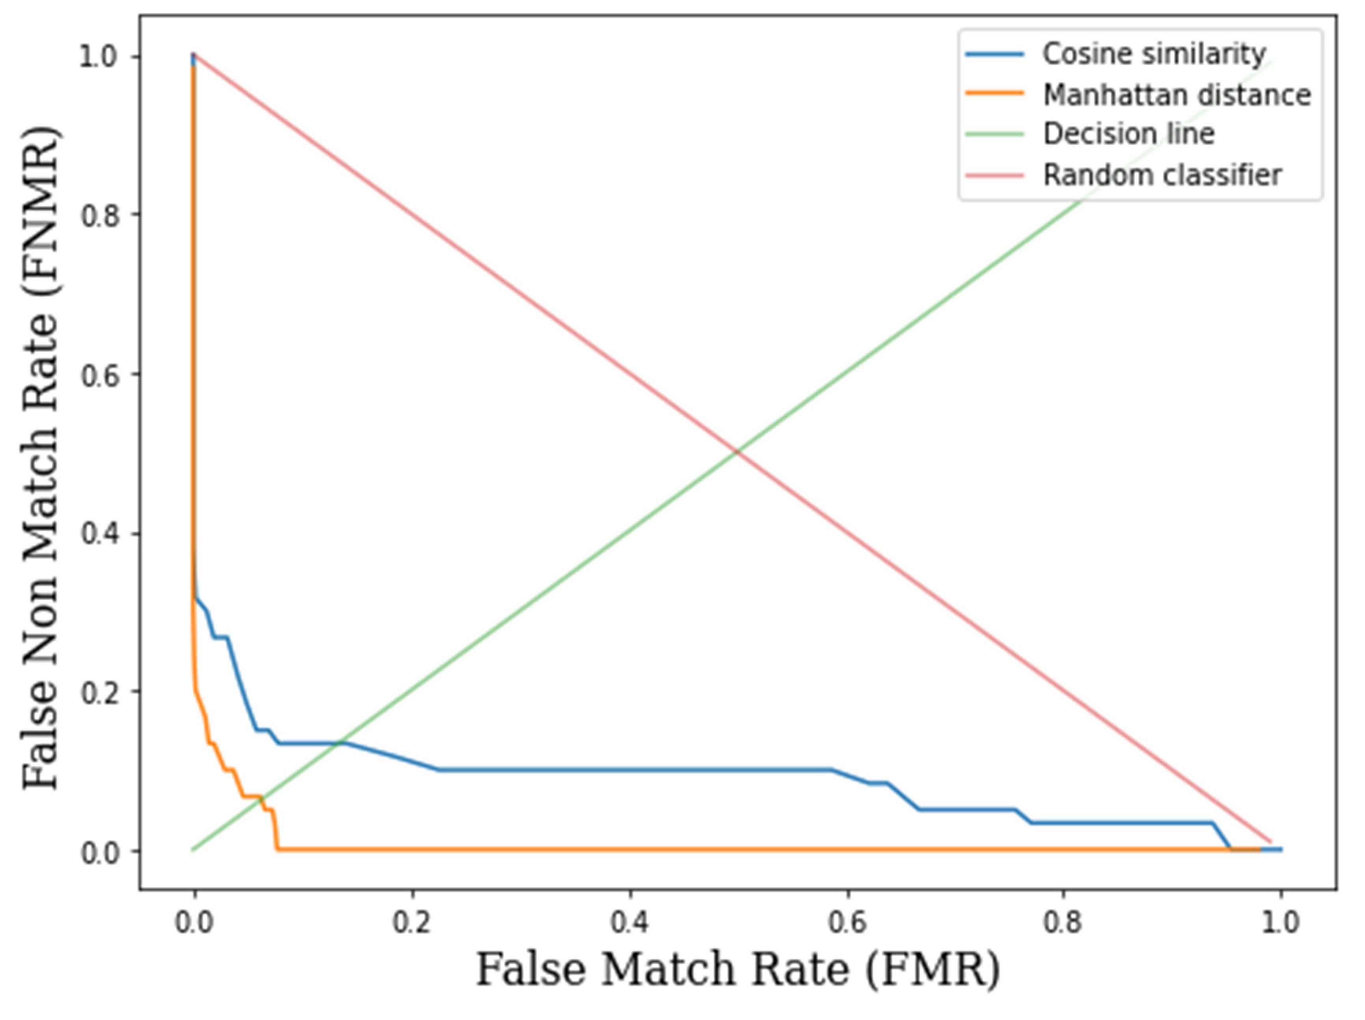
Figure 8. Cosine similarity versus Manhattan distance.
However, the performance gap between the benchmark models and VisGIN is neither wide nor negligible. Nevertheless, it is important to note that even a slight difference in false match rate can lead to a significant number of misclassified samples. Therefore, in scenarios where millions of samples need to be classified, VisGIN can enhance system performance and improve classification accuracy for large-scale applications.

 | $$M =1$$ |  |  | $$M =2$$ |  |  | $$M =3$$
Model | ACC ($↑)$ | FNMR ($↓)$ | FMR ($↓)$ | ACC ($↑)$ | FNMR ($↓)$ | FMR ($↓)$ | ACC ($↑)$ | FNMR ($↓)$ | FMR  ($↓)$
LSTM | 92.98 ± 10.1 | 7.28 | 6.75 | 95.0 ± 7.1 | 4.99 | 4.99 | 95.66 ± 6.0 | 4.42 | 4.26
MLP | 97.15 ± 4.1 | 2.81 | 2.89 | 97.86 ± 2.7 | 2.12 | 2.16 | 98.04 ± 2.3 | 1.89 | 2.0
TCN | 97.29 ± 4.6 | 2.79 | 2.61 | 98.4 ± 2.4 | 1.66 | 1.53 | 98.48 ± 2.2 | 1.53 | 1.52
mWDN | 98.88 ± 2.4 | 1.11 | 1.12 | 98.92 ± 1.8 | 1.11 | 1.05 | 98.94 ± 1.5 | 1.06 | 1.05
XCM | 99.08 ± 2.2 | 0.97 | 0.86 | 99.32 ± 1.3 | 0.69 | 0.65 | 99.36 ± 1.1 | 0.66 | 0.61
FCN | 99.23 ± 1.9 | 0.79 | 0.74 | 99.66 ± 0.9 | 0.35 | 0.33 | 99.72 ± 0.7 | 0.28 | 0.29
LSTM-FCN | 99.24 ± 1.9 | 0.79 | 0.73 | 99.67 ± 0.9 | 0.34 | 0.32 | 99.71 ± 0.7 | 0.28 | 0.30
MLSTM-FCN | 99.27 ± 1.9 | 0.73 | 0.74 | 99.63 ± 0.9 | 0.38 | 0.35 | 99.69 ± 0.7 | 0.30 | 0.31
InceptionTime | 99.36 ± 1.8 | 0.59 | 0.69 | 99.44 ± 1.2 | 0.54 | 0.57 | 99.49 ± 0.9 | 0.52 | 0.51
VisGIN | 99.54 ± 1.5 | 0.5 | 0.42 | 99.67 ± 0.9 | 0.34 | 0.31 | 99.76 ± 0.7 | 0.24 | 0.25
Table 10. Comparison of performance between VisGIN and baseline models. All values are presented in percentage.
Figure 9. ECG pulse signals of a selection of individuals. X-axis and y-axis denote sample numbers and magnitudes (mV), respectively.
Figure 10. Corresponding visibility graphs of the signals in Figure 9.

6. CONCLUSION AND FUTURE DIRECTION

6.1 Conclusion
This thesis outlined the story of GNNs, starting from the most influential sorts and its development. In the first half of this thesis (section 3), the typical use cases of GNNs were taken and a comparative analysis has been made. Starting from section 4, VisGIN model, an innovative graph neural network designed for graph classification tasks using one-dimensional visibility graph inputs, has been introduced. The experiments on the CU-ECG dataset have demonstrated that VisGIN achieves state-of-the-art performance in the biometric authentication task.
The potential applications of VisGIN extend to various domains, including security, health, and finance, where the visibility graph representation is widely employed. Future research can focus on enhancing the representational power of VisGIN for different time-series classification tasks in these fields. Exploring various methods for constructing graphs from one-dimensional signals and investigating combinations of graph machine learning models offer promising avenues for further investigation in the realm of time-series classification with graph neural networks. Moreover, the application of GNNs in telecommunication, as previously explored in literature [83], can provide valuable insights for applying VisGIN to address radio signal representation challenges in the time-series domain.

Limitations: The proposed biometric authentication scheme in this study may have limitations in generalizing to subjects with extreme heart conditions due to the dataset consisting solely of ECG recordings of subjects at ease. While VisGIN has demonstrated its capability in time-series classification and achieved satisfactory results, further improvements are still needed to excel in the broader field of time-series analysis. It is noteworthy that as the number of data samples increases from 1 to 3, the performance gap between VisGIN and other models narrows. This observation suggests that VisGIN's generalization power is more significant when the number of samples per subject is limited. However, challenges in generalization may arise as the number of obtained data samples increases.

6.2 Prospective Future Direction
Considering the outcomes presented in this thesis, following topics were enabled and found notable for future discussion:
- Representational boundaries of GNNs against traditional graph machine learning algorithms
- Time-series analysis using GNNs
- Representing one-dimensional signals with graphs
- Characterization of time-series signals for various tasks such as outlier detection, anomaly detection, regression, etc.
Among these, the most significant output can be said as the success of representing periodical data as graphs. The research question that led us directly to explore the appropriateness of converging GNNs and time-series data was answered by the results of the thesis, which showed that the intuition to apply visibility graph conversion actually preserves the characteristics of the signal.
Following the results of this thesis, we keen on to dive into the prospective future directions as mentioned in this section, particularly in outlier detection and anomaly detection. As seen in Figure 9 & 10, some characteristic points of ECG signals are apparent, especially R points, QRS complexes, peaks of P waves and T waves. Thus, extending this study to prove or disprove the convenience of approaching time-series from the perspective of graph theory is noteworthy.

References

[1] | A. Hogan, E. Blomqvist, M. Cochez, C. D’amato, G. D. Melo, C. Gutierrez, S. Kirrane, J. E. L. Gayo, R. Navigli, S. Neumaier and associates, "Knowledge Graphs," ACM Comput. Surv., vol. 54, no. 4, 2021.
[2] | M. M. Bronstein, J. Bruna, Y. LeCun, A. Szlam and P. Vandergheynst, "Geometric Deep Learning: Going beyond Euclidean data," IEEE Signal Processing Magazine, vol. 34, no. 4, pp. 18-42, 2017.
[3] | Q. Xuan, J. Zhou, K. Qiu, Z. Chen, D. Xu, S. Zheng and X. Yang, "AvgNet: Adaptive Visibility Graph Neural Network and Its Application in Modulation Classification," IEEE Transactions on Network Science and Engineering, vol. 9, no. 3, pp. 1516-1526, 2022.
[4] | S. Wu, M. Liang, X. Wang and Q. Chen, "VGbel: An exploration of ensemble learning incorporating non-Euclidean structural representation for time series classification," Expert Systems with Applications, vol. 224, p. 119942, 2023.
[5] | Z. Wu, S. Pan, F. Chen, G. Long, C. Zhang and P. S. Yu, "A Comprehensive Survey on Graph Neural Networks," IEEE Transactions on Neural Networks and Learning Systems, vol. 32, no. 1, pp. 4-24, 2021.
[6] | E. Choi, Z. Xu, Y. Li, M. Dusenberry, G. Flores, E. Xue and A. Dai, "Learning the Graphical Structure of Electronic Health Records with Graph Convolutional Transformer," Proceedings of the AAAI Conference on Artificial Intelligence, vol. 34, no. 1, pp. 606-613, 2020.
[7] | T. Bian, X. Xiao, T. Xu, P. Zhao, W. Huang, Y. Rong and J. Huang, "Rumor Detection on Social Media with Bi-Directional Graph Convolutional Networks," Proceedings of the AAAI Conference on Artificial Intelligence, vol. 34, no. 1, pp. 549-556, 2020.
[8] | N. Park, A. Kan, X. L. Dong, T. Zhao and C. Faloutsos, "Estimating Node Importance in Knowledge Graphs Using Graph Neural Networks," in Proceedings of the 25th ACM SIGKDD International Conference on Knowledge Discovery & Data Mining, Anchorage, AK, USA, 2019.
[9] | Z. Cui, K. Henrickson, R. Ke and Y. Wang, "Traffic Graph Convolutional Recurrent Neural Network: A Deep Learning Framework for Network-Scale Traffic Learning and Forecasting," IEEE Transactions on Intelligent Transportation Systems, vol. 21, no. 11, pp. 4883-4894, 2020.
[10] | Y.-T. Lin, M.-T. Wu and K.-Y. Su, "Syntax-aware Natural Language Inference with Graph Matching Networks," in 2020 International Conference on Technologies and Applications of Artificial Intelligence (TAAI), Taipei, Taiwan, 2020.
[11] | P. Pradhyumna, G. P. Shreya and Mohana, "Graph Neural Network (GNN) in Image and Video Understanding Using Deep Learning for Computer Vision Applications," in 2021 Second International Conference on Electronics and Sustainable Communication Systems (ICESC), Coimbatore, India, 2021.
[12] | W. Hamilton, Z. Ying and J. Leskovec, "Inductive Representation Learning on Large Graphs," in Advances in Neural Information Processing Systems, Long Beach, CA, 2017.
[13] | J. Gasteiger, A. Bojchevski and S. Günnemann, Predict then Propagate: Graph Neural Networks meet Personalized PageRank, arXiv, 2022.
[14] | F. Wu, A. Souza, T. Zhang, C. Fifty, T. Yu and K. Weinberger, "Simplifying Graph Convolutional Networks," in Proceedings of the 36th International Conference on Machine Learning, Long Beach, CA, 2019.
[15] | P. Veličković, G. Cucurull, A. Casanova, A. Romero, P. Liò and Y. Bengio, "Graph Attention Networks," in International Conference on Learning Representations, Vancouver, BC, Canada, 2018.
[16] | P. Veličković, W. Fedus, W. L. Hamilton, P. Liò, Y. Bengio and R. D. Hjelm, Deep Graph Infomax, arXiv, 2018.
[17] | I. Benjamini and L. Lovász, "Harmonic and analytic functions on graphs," Journal of Geometry, vol. 76, no. 1, p. 3–15, 2003.
[18] | D. K. Duvenaud, D. Maclaurin, J. Iparraguirre, R. Bombarell, T. Hirzel, A. Aspuru-Guzik and R. P. Adams, "Convolutional networks on graphs for learning molecular fingerprints.," in Advances in Neural Information Processing Systems, Montreal, Canada, 2015.
[19] | M. Simonovsky and N. Komodakis, "Dynamic Edge-Conditioned Filters in Convolutional Neural Networks on Graphs," in 2017 IEEE Conference on Computer Vision and Pattern Recognition (CVPR), Honolulu, HI, USA, 2017.
[20] | D. J. Gilmer, S. S. Schoenholz, P. F. Riley, O. Vinyals and G. E. Dahl, "Neural Message Passing for Quantum Chemistry," in Proceedings of the 34th International Conference on Machine Learning, Long Beach, CA, 2017.
[21] | K. Xu, W. Hu, J. Leskovec and S. Jegelka, How powerful are graph neural networks?, arXiv, 2018.
[22] | J. Bruna, W. Zaremba, A. Szlam and Y. LeCun, Spectral networks and locally connected networks on graphs, arXiv, 2013.
[23] | X. Zhu, Z. Ghahramani and J. D. Lafferty, "Semi-supervised learning using Gaussian fields and harmonic functions," in Proceedings of the Twentieth International Conference on Machine Learning, Washington, DC, 2003.
[24] | A. Hagberg, D. S. Chult and P. J. Swart, "Exploring network structure, dynamics, and function using networkx," in Proceedings of the 7th Python in Science conference (SciPy 2008), Pasadena, CA, 2008.
[25] | L. He, C. T. Lu, J. Ma, J. Cao, L. Shen and P. S. Yu, "Joint community and structural hole spanner detection via harmonic modularity," in Proceedings of the 22nd ACM SIGKDD International Conference on Knowledge Discovery and Data Mining, San Francisco, CA, 2016.
[26] | W. W. Zachary, "An information flow model for conflict and fission in small groups," J. Anthropol. Res., vol. 33, p. 452–473, 1977.
[27] | J. Leskovec and A. Krevl, SNAP datasets: Stanford Large Network Dataset Collection, 2014.
[28] | A. Bharali, "An analysis of Email-Eu-Core network," Int. J. Sci. Res. Math. Stat. Sci., vol. 5, p. 100–104, 2018.
[29] | D. Grattarola and C. Alippi, "Graph neural networks in TensorFlow and Keras with Spektral," IEEE Comput. Intell. Mag., vol. 16, p. 99–106, 2021.
[30] | T. N. Kipf and M. Welling, Semi-supervised classification with graph convolutional networks, arXiv, 2016.
[31] | F. Scarselli, M. Gori, A. C. Tsoi, M. Hagenbuchner and M. G., "The graph neural network model," IEEE Trans. Neural Networks, vol. 20, pp. 61-80, 2009.
[32] | I. Kim, S. Han, S.-J. Park, J.-w. Baek, J. Shin, J.-J. Han and C. Choi, "DiscFace: Minimum Discrepancy Learning for Deep Face Recognition," in Computer Vision -- ACCV 2020, Kyoto, Japan, 2021.
[33] | M. Ahsan, M. A. Based, J. Haider and M. Kowalski, "An intelligent system for automatic fingerprint identification using feature fusion by Gabor filter and deep learning," Computers and Electrical Engineering, vol. 95, p. 107387, 2021.
[34] | A. Alzubaidi, S. Roy and J. Kalita, "A data reduction scheme for active authentication of legitimate smartphone owner using informative apps ranking," Digital Communications and Networks, vol. 5, no. 4, pp. 205-213, 2019.
[35] | S. Minaee and A. Abdolrashidi, DeepIris: Iris Recognition Using A Deep Learning Approach, arXiv, 2019.
[36] | M. Knoche, M. Elkadeem, S. Hörmann and G. Rigoll, "Octuplet Loss: Make Face Recognition Robust to Image Resolution," in 2023 IEEE 17th International Conference on Automatic Face and Gesture Recognition (FG), Hawaii, USA, 2023.
[37] | A. Kumar and H. Om, "An improved and secure multiserver authentication scheme based on biometrics and smartcard," Digital Communications and Networks, vol. 4, no. 1, pp. 27-38, 2018.
[38] | Minahil, M. F. Ayub, K. Mahmood, S. Kumari and A. K. Sangaiah, "Lightweight authentication protocol for e-health clouds in IoT-based applications through 5G technology," Digital Communications and Networks, vol. 7, no. 2, pp. 235-244, 2021.
[39] | Z. Zhang, H. Ning, F. Farha, J. Ding and K.-K. R. Choo, "Artificial intelligence in physiological characteristics recognition for internet of things authentication," Digital Communications and Networks, 2022.
[40] | G. Singh, G. Bhardwaj, S. V. Singh and V. Garg, "Biometric Identification System: Security and Privacy Concern," in Artificial Intelligence for a Sustainable Industry 4.0, Springer International Publishing, 2021, pp. 245--264.
[41] | I. u. haq, J. Wang, Y. Zhu and S. Maqbool, "An efficient hash-based authenticated key agreement scheme for multi-server architecture resilient to key compromise impersonation," Digital Communications and Networks, vol. 7, no. 1, pp. 140-150, 2021.
[42] | U. Uludag and A. K. Jain, "Attacks on biometric systems: a case study in fingerprints," in Security, Steganography, and Watermarking of Multimedia Contents VI, San Jose, CA, 2004.
[43] | Y. Zhang, C. Gao, S. Pan, Z. Li, Y. Xu and H. Qiu, "A Score-Level Fusion of Fingerprint Matching With Fingerprint Liveness Detection," IEEE Access, vol. 8, pp. 183391-183400, 2020.
[44] | L. Biel, O. Pettersson, L. Philipson and P. Wide, "ECG analysis: a new approach in human identification," IEEE Transactions on Instrumentation and Measurement, vol. 50, no. 3, pp. 808-812, 2001.
[45] | I. Odinaka, P. H. Lai, A. D. Kaplan, J. A. O'Sullivan, E. J. Sirevaag and J. W. Rohrbaugh, "ECG Biometric Recognition: A Comparative Analysis," IEEE Transactions on Information Forensics and Security, vol. 7, no. 6, pp. 1812-1824, 2012.
[46] | M. Ingale, R. Cordeiro, S. Thentu, Y. Park and N. Karimian, "ECG Biometric Authentication: A Comparative Analysis," IEEE Access, vol. 8, pp. 117853-117866, 2020.
[47] | T. W. Shen, W. J. Tompkins and Y. H. Hu, "One-lead ECG for identity verification," in Proceedings of the Second Joint 24th Annual Conference and the Annual Fall Meeting of the Biomedical Engineering Society] [Engineering in Medicine and Biology, Houston, TX, USA, 2002.
[48] | A. D. C. Chan, M. M. Hamdy, A. Badre and V. Badee, "Person Identification using Electrocardiograms," in 2006 Canadian Conference on Electrical and Computer Engineering, Ottawa, ON, Canada, 2006.
[49] | K. N. Plataniotis, D. Hatzinakos and J. K. M. Lee, "ECG Biometric Recognition Without Fiducial Detection," in 2006 Biometrics Symposium: Special Session on Research at the Biometric Consortium Conference, Baltimore, MD, USA, 2006.
[50] | S. I. Safie, J. J. Soraghan and L. Petropoulakis, "Electrocardiogram (ECG) Biometric Authentication Using Pulse Active Ratio (PAR)," IEEE Transactions on Information Forensics and Security, vol. 6, no. 4, pp. 1315-1322, 2011.
[51] | J. Shen, S.-D. Bao, L.-C. Yang and Y. Li, "The PLR-DTW method for ECG based biometric identification," in 2011 Annual International Conference of the IEEE Engineering in Medicine and Biology Society, Boston, MA, USA, 2011.
[52] | S. Wahabi, S. Pouryayevaliand, S. Hari and D. Hatzinakos, "On Evaluating ECG Biometric Systems: Session-Dependence and Body Posture," IEEE Transactions on Information Forensics and Security, vol. 9, no. 11, pp. 2002-2013, 2014.
[53] | M. Komeili, W. Louis, N. Armanfard and D. Hatzinakos, "Feature Selection for Nonstationary Data: Application to Human Recognition Using Medical Biometrics," IEEE Transactions on Cybernetics, vol. 48, no. 5, pp. 1446-1459, 2018.
[54] | H.-S. Choi, B. Lee and S. Yoon, "Biometric Authentication Using Noisy Electrocardiograms Acquired by Mobile Sensors," IEEE Access, vol. 4, pp. 1266-1273, 2016.
[55] | J. S. Paiva, D. Dias and J. P. S. Cunha, "Beat-ID: Towards a computationally low-cost single heartbeat biometric identity check system based on electrocardiogram wave morphology," PLOS ONE, vol. 12, no. 7, pp. 1-32, 2017.
[56] | E. Kalai Zaghouani, A. Benzina and R. Attia, "ECG based authentication for e-healthcare systems: Towards a secured ECG features transmission," in 2017 13th International Wireless Communications and Mobile Computing Conference (IWCMC), Valencia, Spain, 2017.
[57] | Q. Zhang, D. Zhou and X. Zeng, "HeartID: A Multiresolution Convolutional Neural Network for ECG-Based Biometric Human Identification in Smart Health Applications," IEEE Access, vol. 5, pp. 11805-11816, 2017.
[58] | R. Tan and M. Perkowski, "Toward improving electrocardiogram (ECG) biometric verification using mobile sensors: A two-stage classifier approach," Sensors, vol. 17, no. 2, p. 410, 2017.
[59] | S.-K. Kim, C. Y. Yeun and P. D. Yoo, "An Enhanced Machine Learning-Based Biometric Authentication System Using RR-Interval Framed Electrocardiograms," IEEE Access, vol. 7, pp. 168669-168674, 2019.
[60] | R. Li, G. Yang, K. Wang, Y. Huang, F. Yuan and Y. Yin, "Robust ECG biometrics using GNMF and sparse representation," Pattern Recognition Letters, vol. 129, pp. 70-76, 2020.
[61] | V. Mai, I. Khalil and C. Meli, "ECG biometric using multilayer perceptron and radial basis function neural networks," in 2011 Annual International Conference of the IEEE Engineering in Medicine and Biology Society, Boston, MA, USA, 2011.
[62] | R. D. Labati, E. Muñoz, E. Piuri, R. Sassi and F. Scotti, "Deep-ECG: Convolutional neural networks for ECG biometric recognition," Pattern Recognition Letters, vol. 126, pp. 78--85, 2019.
[63] | P.-L. Hong, J.-Y. Hsiao, C.-H. Chung, Y.-M. Feng and S.-C. Wu, "ECG Biometric Recognition: Template-Free Approaches Based on Deep Learning," in 2019 41st Annual International Conference of the IEEE Engineering in Medicine and Biology Society (EMBC), Berlin, Germany, 2019.
[64] | Y. Li, Y. Pang, K. Wang and X. Li, "Toward improving ECG biometric identification using cascaded convolutional neural networks," Neurocomputing, vol. 391, pp. 83--95, 2020.
[65] | Y. Chu, H. Shen and K. Huang, "ECG Authentication Method Based on Parallel Multi-Scale One-Dimensional Residual Network With Center and Margin Loss," IEEE Access, vol. 7, pp. 51598-51607, 2019.
[66] | R. Salloum and C. -C. J. Kuo, "ECG-based biometrics using recurrent neural networks," in 2017 IEEE International Conference on Acoustics, Speech and Signal Processing (ICASSP), New Orleans, LA, 2017.
[67] | Ö. Yildirim, "A novel wavelet sequence based on deep bidirectional LSTM network model for ECG signal classification," Computers in biology and medicine, vol. 96, pp. 189--202, 2018.
[68] | H. M. Lynn, S. B. Pan and P. Kim, "A Deep Bidirectional GRU Network Model for Biometric Electrocardiogram Classification Based on Recurrent Neural Networks," IEEE Access, vol. 7, pp. 145395-145405, 2019.
[69] | D. A. AlDuwaile and M. S. Islam, "Using convolutional neural network and a single heartbeat for ECG biometric recognition," Entropy, vol. 23, no. 6, p. 733, 2021.
[70] | D. Jyotishi and S. Dandapat, "An ECG Biometric System Using Hierarchical LSTM With Attention Mechanism," IEEE Sensors Journal, vol. 22, no. 6, pp. 6052-6061, 2022.
[71] | J. P. Allam, K. P. Kiran, H. Mohamed, T. Ryszard and P. Pławiak, "BAED: A secured biometric authentication system using ECG signal based on deep learning techniques," Biocybernetics and Biomedical Engineering, vol. 42, no. 4, pp. 1081--1093, 2022.
[72] | J.-A. Lee and K.-C. Kwak, "Personal Identification Using an Ensemble Approach of 1D-LSTM and 2D-CNN with Electrocardiogram Signals," Applied Sciences, vol. 12, no. 5, p. 2692, 2022.
[73] | G.-H. Choi, E.-S. Bak and S.-B. Pan, "User Identification System Using 2{D} Resized Spectrogram Features of ECG," IEEE Access, vol. 7, pp. 34862-34873, 2019.
[74] | S. Hochreiter and J. Schmidhuber, "Long Short-Term Memory," Neural Computation, vol. 9, no. 8, pp. 1735-1780, 1997.
[75] | J. Wang, Z. Wang, J. Li and J. Wu, "Multilevel wavelet decomposition network for interpretable time series analysis," in Proceedings of the 24th ACM SIGKDD International Conference on Knowledge Discovery & Data Mining, New York, NY, USA, 2018.
[76] | K. Fauvel, T. Lin, V. Masson, É. Fromont and A. Termier, "XCM: An explainable convolutional neural network for multivariate time series classification," Mathematics, vol. 9, no. 23, p. 3137, 2021.
[77] | Z. Wang, W. Yan and T. Oates, "Time series classification from scratch with deep neural networks: A strong baseline," in 2017 International joint conference on neural networks (IJCNN), Anchorage, AK, 2017.
[78] | F. Karim, S. Majumdar, H. Darabi and S. Chen, "LSTM fully convolutional networks for time series classification," IEEE Access, vol. 6, pp. 1662--1669, 2017.
[79] | F. Karim, S. Majumdar, H. Darabi and S. Harford, "Multivariate LSTM-FCNs for time series classification," Neural Networks, vol. 116, pp. 237--245, 2019.
[80] | H. I. Fawaz, B. Lucas, G. Forestier, C. Pelletier, D. F. Schmidt, J. Weber, G. I. Webb, L. Idoumghar, P.-A. Muller and F. Petitjean, "InceptionTime: Finding AlexNet for time series classification," Data Mining and Knowledge Discovery, vol. 34, no. 6, pp. 1936--1962, 2020.
[81] | I. Oguiza, tsai - A state-of-the-art deep learning library for time series and sequential data, 2022.
[82] | A. Sargolzaei, K. Faez and S. Sargolzaei, "A new robust wavelet based algorithm for baseline wandering cancellation in ECG signals," in 2009 IEEE International Conference on Signal and Image Processing Applications, Kuala Lumpur, Malaysia, 2009.
[83] | Q. Xuan, J. Zhou, K. Qiu, Z. Chen, D. Xu, S. Zheng and X. Yang, "AvgNet: Adaptive Visibility Graph Neural Network and Its Application in Modulation Classification," IEEE Transactions on Network Science and Engineering, vol. 9, no. 3, pp. 1516-1526, 2022.

Acknowledgements

[Will be written in later stages]

Publications from the Thesis
Hacı İsmail Aslan, Hoon Ko, and Chang Choi. "Classification of vertices on social networks by multiple approaches.", Mathematical Biosciences and Engineering, 19 (12), 12146-12159, doi: 10.3934/mbe.2022565
Hacı İsmail Aslan and Choi, Chang, “VisGIN: Visibility Graph Neural Network on One-Dimensional Data for Biometric Authentication”. Available at SSRN: https://ssrn.com/abstract=4423327 or http://dx.doi.org/10.2139/ssrn.4423327

