Thesis for Master’s Degree

Representational Power of Graph Neural Networks: A Novel Study of Graph Neural Networks on Time-Series
그래프 신경망의 표현력: 시계열에 대한 그래프 신경망에 대한 새로운 연구

Hacı İsmail Aslan
Computer Engineering Major
Department of IT Convergence Engineering
Graduate School
Gachon University

Thesis for M.S. Degree
Supervised by Professor Chang Choi

Representational Power of Graph Neural Networks: A Novel Study of Graph Neural Networks on Time-Series
그래프 신경망의 표현력: 시계열에 대한 그래프 신경망에 대한 새로운 연구

Submitted in Fulfillment of the Requirements for the Degree of IT Convergence Engineering
May, 2023
Hacı İsmail Aslan
Computer Engineering Major
Department of IT Convergence Engineering
Graduate School
Gachon University
This certifies that the master’s thesis of Hacı İsmail Aslan is approved
May, 2023

Committee Chairman (seal)

Committee Member (seal)

Committee Member (seal)

Committee Member (seal)

Committee Member (seal)

Abstract
The field of graph-based data analysis has recently gained attention due to the increasing popularity of non-tabular data formats. Examples of such data include social networks, data flow maps, citation influence graphs, and protein bindings. As the number of applications representing graph data increases, the representational power of these applications comes into question. Therefore, this thesis first evaluates the representational power of some of the main graph machine learning models. Second, it applies a novel method that utilizes Graph Neural Networks (GNN) for biometric authentication tasks, enabling GNNs to generalize time-series data.
The labeling of discrete communities in social networks is critical for analyzing graph networks, and several artificial intelligence approaches have been evaluated for partitioning vertices based on topological features. In this context, the "harmonic functions" method was found to be the most effective for classifying constituents of graph-shaped datasets, when it comes to supervised learning. Furthermore, this research in the first chapter, sheds light on the limitations of graph neural networks in comparison to non-neural network approaches, which are faster and computationally cost-effective. In the second chapter, this thesis mentions electrocardiogram (ECG) signals that have been widely used as a biometric authentication method in the field of cybersecurity. A novel method, the VisGIN model, which utilizes Graph Isomorphism Network Convolution (GINConv) for the convolutional layers and visibility graphs as input, has been proposed for ECG authentication. The second chapter shows that the VisGIN approach achieves high classification accuracy in grant-access decisions, making graph machine learning models applicable for time-series binary classification tasks, particularly in ECG authentication.

Contents
1. INTRODUCTION 1
1.1 Background 1
1.2 Research Motivation 2
1.3 Problem Statements 2
1.4 Main Contributions 2
1.5 Composition of the Thesis 2
2. BACKGROUND 3
2.1 Graph Neural Networks 3
2.1.1 Spatial Approaches 5
2.1.2 Spectral Approaches 7
2.2 Harmonic Functions 8
2.3 Visibility Graphs 9
2.4 Time-Series Data and Electrocardiogram (ECG) 10
3. EXPLORING GNNs ON EXTRACTING NODE EMBEDDINGS 13
3.1 Graph Data 13
3.2 Comparison of GNNs and Harmonic Functions 15
3.2.1 Graph Convolutional Networks (GCN) 15
3.2.2 Graph Attention Networks (GAT) 18
4. GNN FOR ECG BIOMETRIC AUTHENTICATION 19
4.1 Biometric Authentication with Machine Learning 19
4.1.1 Where Biometric Authentication Fails 20
4.1.2 ECG Biometric Authentication Excels 22
4.1.3. Related Work 22
4.2 Proposed Method for Biometric Authentication 22
4.3 Proposed Method for Time-Series Classification with Graph Neural Networks 22
5. IMPLEMENTATION ENVIRONMENT, RESULTS AND DISCUSSION 22
5.1 Environment Details 22
5.2 Results for Node Classification 23
5.3 Results for Biometric Authentication with VisGIN 23
6. CONCLUSION AND FUTURE DIRECTION 23
6.1 Conclusion 23
6.2 Prospective Future Direction 23
References 23
Acknowledgements 28
Publications from the Thesis 28

List of Tables

List of Figures

INTRODUCTION

1.1 Background
Social networks are becoming increasingly prevalent in the modern era, and the exchange of information in these networks can take various forms such as physical contact, messaging, collaboration, and emotional closeness. These networks can be represented as knowledge maps, which take the form of a graph structure [1]. Analyzing data in graph format is essential for gaining insights into social networks.
Data is typically represented in a tabular or non-Euclidean format to facilitate structured analysis [2]. In tabular format, data is organized as rows and columns, and there is no inherent relationship between samples. However, in real-world scenarios, samples are often interdependent and have connections to other samples across multiple topics. Graph networks are useful in such scenarios, as they can capture the relationships between samples and represent them with links. Later sections will delve into the mathematical foundations of graph networks.
Being graph specific, the research of GNNs on time-series is still a hot topic [3, 4]. The approach to the time series classification from the perspective of graph domain influenced this thesis. Thus, this thesis, first investigates the limits of graph machine learning models on its natural domain such as social networks, and then proposes a new scheme for biometric authentication using ECG signals and graph isomorphism networks.

1.2 Research Motivation

1.3 Problem Statements

1.4 Main Contributions

1.5 Composition of the Thesis

BACKGROUND

2.1 Graph Neural Networks
Graph neural networks, or GNNs, have become a popular approach for processing graph-structured data, due to their ability to capture both the structural and attribute information of the nodes in the graph. GNNs typically consist of multiple layers, where each layer performs a message-passing operation on the graph to update the node representations based on their local neighborhood structure.
A Graph Neural Network [5] is a neural network that can handle non-Euclidean data, making it a novel method for grid-wise graph inputs that show intercorrelations between samples and evaluate various tasks. GNNs are becoming increasingly popular and have been applied in various fields, such as molecular biology [6], network sociology [7], knowledge graphs [8], road traffic [9], natural language processing [10], and computer vision [11]. Recent developments in different versions of GNNs, including GCN, GraphSAGE [12], APPNP [13], SGC [14], GAT [15], and DGI [16], have led to the growth and dissemination of this area of neural networks. Among these variations, GCN and GAT are exemplary since one leads the convolutional approaches, while the other leads the attention-based mechanisms. In addition to variations of GNNs, other learning methods such as random walks, spectral graph theory applications, nearest neighbor approach, and harmonic functions [17] are notable. The latter is explained in the following sections of this thesis in depth.
The key feature of GNNs is their use of graph convolutional layers, which operate on the adjacency matrix and node feature matrix to aggregate information from neighboring nodes and update node representations. These layers use a learnable kernel to weight the contributions of neighboring nodes, allowing for the propagation of information across the graph.
Another important aspect of GNNs is the use of graph pooling layers, which are used to down-sample the graph and reduce its complexity. Graph pooling is typically performed by selecting a subset of nodes and aggregating their features into a single node, which can then be used as a summary representation of the original subgraph.
At the end of the GNN, a graph-level representation is obtained, which is used for the final classification task. This output is typically passed through a fully connected layer followed by a softmax function to obtain a probability distribution over the possible classes. The use of graph-level representations allows GNNs to handle graphs of varying sizes and structures, making them useful for a wide range of applications, including social networks, biological networks, and knowledge graphs.
In recent years, GNNs have shown impressive performance on a variety of tasks, including node classification, link prediction, and graph classification. However, there are still many open research questions, including the scalability of GNNs to large graphs, the robustness of GNNs to noisy data, and the interpretability of GNNs, among others. Overall, GNNs represent a promising avenue for processing graph-structured data and are likely to play an increasingly important role in the field of machine learning in the years to come.
In the literature, there are various types of GNN layers. Hence, a short summary of the intuition behind this research field is given in sections 2.1.1 and 2.1.2.

2.1.1 Spatial Approaches
In a study by Duvenaud et al. in 2015 [18], they proposed a novel spatial methodology where they began by setting up the feature vector $f^{t}\left(v\right)$ for every node in the graph. The researchers subsequently computed feature embeddings for each node 𝑣 in every iteration using Equation 1, and $N$ denoted the set of neighboring nodes. Following this, a linear layer was employed before applying the activation function of softmax, as presented in Equation 2.
$$f^{t}\left(v\right)=f^{t-1}\left(v\right) +\sum_{w∈N\left(v\right)}{f^{t-1}\left(w\right)} (1)$$
$$f^{t}\left(v\right)=\text{softmax}\left(f^{t}\left(v\right)⋅H^{t}\right) \left(2\right)$$
In another study, Simonovsky and Komodakis introduced a GNN layer called "Edge-Conditioned Convolution" that utilized mean-field inference [19]. In their research, they derived the feature vector $f^{t}\left(v\right)$ for node $v$ at layer $t$ using Equation 3, where $W$ represents the parameter matrix and $l\left(w,v\right)$ is the label of the edge shared between nodes $w$ and $v$.
$$f^{t}\left(v\right)=1/\left|N\left(v\right)\right|\sum_{w∈N\left(v\right)}{F^{l}\left(l\left(w,v\right),W\left(l\right)\right)⋅f^{t-1}\left(w\right)+b^{l} } \left(3\right)$$
Similarly, Gilmer and colleagues conducted an investigation where they devised a message-passing structure, drawing on several of the GNN models discussed up to this point [20]. Their approach calculates the feature representation as shown in Equation 4. It is worth noting that $f_{\text{aggr}}^{W_{2}}$ sums the set of neighboring features, while $f_{\text{merge}}^{W_{1}}$ combines the node's embedding from the previous stage with the neighborhood embeddings in the final step.
$$f_{\text{merge}}^{W_{1}}\left(f^{t-1}\left(v\right),f_{\text{aggr}}^{W_{2}}\left(\{\{f^{t-1}\left(w\right) | w∈N\left(v\right)\}\}\right)\right) \left(4\right)$$
Section 4 provides an explanation that Xu and colleagues have raised doubts about the expressive power of GNN architectures [21]. They have demonstrated that the Weisfellar-Lehman algorithm limits its expressiveness. Essentially, they have established that no GNN model can differentiate between two non-isomorphic graphs. As a solution, they have introduced the Graph Isomorphism Network (GIN). In GIN, the calculation of the feature representation of node $v$ at layer $t$ is presented in Equation 5.
$$f^{t}\left(v\right)=MLP\left(\left(1+ϵ\right)⋅f^{t-1}\left(v\right)+\sum_{w∈N\left(v\right)}{f^{t-1}\left(w\right)}\right) \left(5\right)$$
The latter model has a huge impact on this thesis in terms of defining the VisGIN architecture that will be defined later.

2.1.2 Spectral Approaches
In spectral methodologies, when dealing with an undirected graph having $n$ nodes and an adjacency matrix $A$, the Laplacian matrix is obtained using Equation 6, and it is subjected to a convolution operation. It is noteworthy to mention that the diagonal matrix $D$ represents the degrees of the nodes. The factorization of $L$ is accomplished using Equation 7, where $U$ is the matrix containing eigenvectors and $Λ$ is the diagonal matrix.
$L=I-D^{-1/2}AD^{-1/2} \left(6\right)$
$$L=U Λ U^{⊤} \left(7\right)$$
Based on Equation 8, when $x$ is a graph, spectral methods are utilized to extend convolution to graphs. The convolution filter learned is labeled as $g$. The computation is clarified in Equation 9 and abbreviated in Equation 10 through the consideration of ${\text{g}}_{\text{θ}}=\text{diag}\left(U^{⊤\text{g}}\right)$.
$F\left(x\right)=U^{⊤}x \text{and} F^{-1}\left(\hat{x}\right)=Ux \left(8\right)$
$$x*\text{g}=U\left(U^{⊤}X⊙U^{⊤}g\right)=U⋅\text{diag}\left(U^{⊤}g\right)⋅U^{⊤}X \left(9\right)$$
$x*{\text{g}}_{\text{θ}}=U{\text{g}}_{\text{θ}}U^{⊤}X \left(10\right)$
In the context, ${\text{g}}_{\text{θ}}$ plays a pivotal role as the majority of spectral techniques fail to converge when incorporating the trained convolutional filter. Specifically, Bruna et al. (2013) proposed Spectral Convolutional Neural Networks, which adopt ${\text{g}}_{\text{θ}}$ as a collection of adjustable parameters denoted as $Θ_{i,j}^{t}$ [22]. As described in Equation 11, they present the formulation of the spectral Graph Neural Network layer they developed.
$$H_{j}^{t}=σ\left(\sum_{i=1}^{t}{U}Θ_{i,j}^{t}U^{⊤}H_{i}^{t-1}\right) \left(11\right)$$

Harmonic Functions
In mathematics, a harmonic function is a function that satisfies Laplace's equation, which describes the behavior of various physical phenomena such as heat conduction, fluid flow, and electrostatics. Essentially, a harmonic function is one that has no sources or sinks and is "smooth" or "uniform" across the domain it is defined on. In graph theory, harmonic functions are defined in terms of the Laplacian matrix, which is a matrix representation of the graph's connectivity structure. The Laplacian matrix is used to define a discrete Laplacian operator, which can be used to solve various problems on graphs, including classification tasks.
Harmonic functions are particularly useful for classification tasks in graph-based data analysis because they capture the underlying structure of the graph and can be used to infer information about the graph's vertices and edges. They have been used in a variety of applications, including image segmentation, social network analysis, and recommendation systems.
Zhe et al. propose a semi-supervised learning approach that employs Gaussian fields and harmonic functions, suitable for networks with a known topology [23]. The NetworkX library's API [24] is used to implement this classification technique on datasets in section 3. Harmonic functions are explained in Equation 12, where a function $h : V→R$ is deemed harmonic if the graph $G=\left(V,E\right)$ is also harmonic. The degree of the vertex is denoted as $d_{i}$. To gain a better understanding of the harmonic functions' classification, one can refer to He et al.'s work, which provides ample information on the subject [25].
$$h\left(V_{i}\right)=\frac{1}{d_{i}}\sum_{\left(V_{i},V_{j}\right)∈V}{h\left(V_{j}\right)} (12)$$
Overall, harmonic functions are a powerful tool for analyzing graphs and are an important technique in the field of machine learning and data science.

Visibility Graphs

A visibility graph is a topologic representation of discrete entities, where each entity is represented as a node, and an edge is established between two nodes if and only if the corresponding entities are mutually observable. The notion of visibility varies depending on the system or network being investigated. For instance, in the realm of image processing, visibility can be defined as the presence of an unobstructed path between two pixels. In this case, the visibility graph can be used to analyze the image's topological properties, such as the number of connected components, degree distribution, and clustering coefficient. In computer vision, visibility can be defined as the existence of a direct line of sight between two points in 3D space. In this instance, the visibility graph can be used to examine the scene's geometric characteristics, such as the angle distribution, point depth, and surface curvature. Visibility graphs have been shown to be beneficial in various fields of study, not only for the analysis of images, computer vision, and physics, but also for other areas such as time series analysis, signal processing, and even social networks. In this study, visibility graphs were employed as a transformation method for converting time series to graphs.
An edge is created between nodes $N_{i}$ and $N_{j}$ only when the following conditions are met. The maximum slope, ${slope}_{max}$ , is the slope of the line connecting the target node to its adjacent node on the right, $X$ represents the amplitude, and $t$ represents the signal's time step. Initially, the ${slope}_{max}$ for adjacent nodes is set to $-∞$ since these nodes must have an edge between them.
$$E_{ij}∈E,∃!E_{ij}⟺\frac{X\left[i\right]-X\left[j\right]}{t\left[i\right]-t\left[j\right]}>slope_{max} (13)$$
To construct edges in visibility graphs, Equation 13 is employed iteratively for the target node $N_{i}$ and all nodes to the right of the target node $N_{j}$ starting from the nearest neighbor to the farthest. In each iteration, ${slope}_{max}$ is updated to be the slope between the target node and the neighboring node.

Time-Series Data and Electrocardiogram (ECG)
Time-series data refers to data that is recorded and arranged in a chronological order. It is utilized in various fields, such as healthcare, finance, and economics. Electrocardiogram (ECG) is an example of time-series data that measures the heart's electrical activity over time.
In the medical field, ECG data is commonly used for the diagnosis and monitoring of various cardiac conditions. It provides vital information about the heart's function and helps medical practitioners make informed decisions about patient care.
ECG data is collected through an ECG machine that uses electrodes attached to the skin to detect the heart's electrical activity. The data obtained is a series of waveforms that illustrate the heart's electrical activity over time.
The analysis of ECG data requires specialized knowledge, training, and software tools. It can be used to identify abnormal heart activity and monitor changes in the heart's function over time.
Overall, ECG data is a valuable resource for healthcare providers as it provides insights into the heart's function and helps guide patient care.
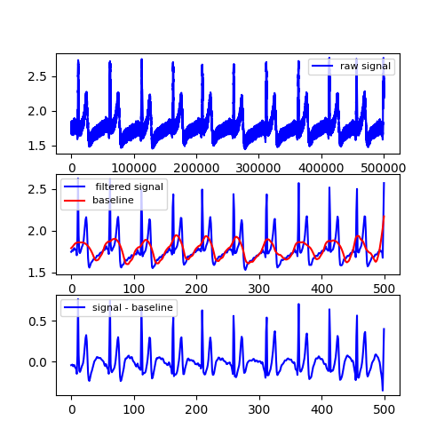
Figure 1. A sample of ECG signal for 10 seconds, its filtered form, and applying baseline correction, respectively.

3. EXPLORING GNNs ON EXTRACTING NODE EMBEDDINGS

Graph Data
To evaluate the throughput of research, it is crucial to carefully select appropriate data sets for processing with specific algorithms. As a result, researchers initially tested entire algorithms using a dataset known as "Zachary's Karate Club Dataset," which was created by Zachary et al. in 1977 [26]. The dataset is referred to as the "Karate Dataset" in this article and is selected based on its simplicity. It comprises 34 members of a local karate club, represented by vertices, and their social interactions, represented by edges. The club was later divided into two subgroups due to an internal dispute among officials, and the objective is to predict each student's final decision on which course to take. Figure 1 depicts the class instructors, represented by nodes 0 and 33.
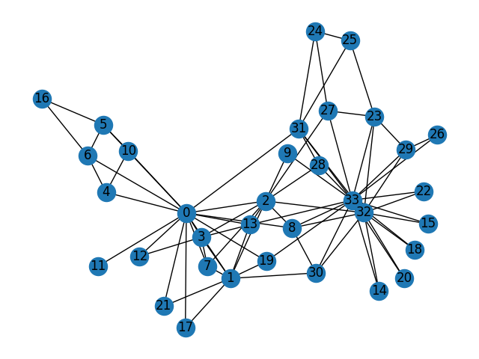
Figure 2. Zachary's karate club dataset.
A testbench dataset was obtained from a large European research institution and utilized in this study. The "Email-Eu-Core network" was chosen from the SNAP network repository [27] and analyzed by Bharali et al. [28]. The authors found that the network is a Small-World network that follows a power law regime and has an assortative mixing pattern on the degree of nodes. Furthermore, the network was found to be resistant to random failures but susceptible to targeted attacks. The average degree of the network, which is the number of edges compared to the number of nodes, was relatively high compared to other datasets analyzed in this study. The internal mailing network represented in the graph network, referred to as the "Email Dataset," had some differences that made it a suitable candidate for node classification. Despite its challenging structure, this dataset was selected as one of the benchmark datasets for this study.
Two datasets, the "Cora" and "Pubmed" datasets, are noteworthy and were utilized in the research presented. Both datasets comprise scientific articles and their corresponding citation linkages. In both citation networks, nodes represent papers, while edges represent citations. The Spektral library [29] was used to obtain these datasets in the form of adjacency matrices. The citation networks are commonly utilized in graph theory to generalize classification results, which are discussed in the subsequent "Results" section. However, the Pubmed dataset presented a challenge due to its high average clustering coefficient. This coefficient refers to the likelihood of drawing a triangle with a node and its two distinct neighbors and can be interpreted as the fraction of closed triplets in the network graph.
 | Karate | Email | Cora | Pubmed
No. Nodes | 34 | 1.005 | 2.708 | 19.717
No. Edges | 78 | 25.571 | 5.429 | 44.338
No. Clusters | 2 | 42 | 7 | 3
No. Training Nodes | 2 | 804 | 2.166 | 5.000
Average Clustering Coefficient | 0.57 | 0.4 | 0.24 | 0.06
Average Degree | 4.59 | 25.44 | 3.9 | 4.5
Table 1. Summary of datasets used for node classification.

3.2 Comparison of GNNs and Harmonic Functions
To achieve the objectives of this research, two types of neural networks were utilized on the datasets and discussed in the subsequent subsections. Although there are numerous models that can be employed for classification tasks, this study focused on comparing harmonic functions with GCN and GAT. The aim was to establish a higher accuracy limit compared to the lower limit set by harmonic functions, thereby providing future neural network models with a benchmark for classification tasks.

3.2.1 Graph Convolutional Networks (GCN)
Graph Convolutional Networks (GCNs), introduced by Kipf et al. (2017) [30], represent an improvement over neural networks operating on graphs that were previously introduced by Gori et al. (2005) [31]. To facilitate comprehension, it is useful to present the mathematical foundations of GCNs. GCNs operate on an adjacency matrix A in the shape of $N × N$ and a feature matrix $H$ in the shape of $N × F$, where each vertex has a 2-D feature vector in the shape of $1 × F$. The fundamental propagation rule for a GCN is expressed by Equation 14.
$H^{'}=σ\left(AHW\right) \left(14\right)$
It should be noted that the weight matrix $W$ has dimensions $F×F^{'}$, $H^{'}$ denotes the newly generated node features, and $σ\left(⋅\right)$ denotes the non-linearity function. To simplify the sum of transformed features of all connected nodes for node $i$, Equation 15 was formulated to describe the correlation between node $i$'s features $h_{i}$ and the features of the nodes $h_{j}$ connected to node $i$. Please note that $V\left(i\right)$ represents the set of neighboring nodes of node $i$.
$$h_{i}=σ\left(\sum_{j∈V\left(i\right)}{W^{T}}h_{j}\right) \left(15\right)$$
Contrary to the earlier statement, the previous propagation rule based on the sum-pooling method is not always effective. This is due to the fact that the propagation rule presented in Equation 15 merely sums the feature vectors, which may cause the feature vectors to increase in scale with repeated applications. To address this issue, another update rule described by Equation 16 normalizes the adjacency matrix by multiplying it with the inverse of the diagonal degree matrix D. As a result, the newly updated node feature vector is represented by Equation 17.
$$H^{'}=σ\left(D^{-1}AHW\right) (16)$$
$$h_{i}^{'}=σ\left(\sum_{j∈V\left(i\right)}{\frac{1}{\left|V\left(i\right)\right|}}W^{T}h_{j}\right) \left(17\right)$$
The previous section outlined the propagation rules used in GCNs. Another important rule, known as symmetric normalization, can be derived from these equations and is shown in Equation 18. This rule involves multiplying the adjacency matrix by the square root of the inverse of the diagonal degree matrix, leading to a change in the node features as shown in Equation 19.
$$H^{'}=σ\left(D^{-1/2}AD^{-1/2}HW\right) (18)$$
$$h_{i}^{'}=σ\left(\sum_{j∈V\left(i\right)}{\frac{1}{\sqrt{\left|V\left(i\right)\right| \left|V\left(j\right)\right|}}}W^{T}h_{j}\right) (19)$$
In this section, GCN was implemented based on the theoretical foundations discussed in this section. However, the focus of this study was on working with the topological relationships of graph-structured data without considering any information related to nodes. Therefore, the features for each node were initially set to zero. Compared results are present in section 5 of this thesis.

3.2.2 Graph Attention Networks (GAT)
In their 2018 paper, Veličković et al. introduced Graph Attention Networks (GATs) as a novel approach that builds on the background of GCNs but incorporates specific "attention" mechanisms. While the mathematical foundations of GAT can be found in the original paper [15], it is important to highlight the unique extensions of GAT in the context of this study.
Unlike GCN, the coefficients in GAT are not fixed, as the coefficients are now dependent on the current input. This approach motivates the use of attention mechanisms in graph neural networks. With non-constant coefficients, the attention coefficient $α_{ij}$ for the receiver node $i$ and sender node $j$ is computed as shown in Equation 20.
$$α_{ij}=\frac{ exp(LeakyReLU(a[W^{T}h_{i}|| W^{T}h_{j}]))}{\sum_{k∈V\left(i\right)}^{n}{exp(LeakyReLU(a[W^{T}h_{i}|| W^{T}h_{k}]))}} (20)$$
To apply GAT in practice, a one-layered MLP denoted by $a$ is applied on concatenated messages $W^{T}h_{i}$ and $W^{T}h_{i}$ using the LeakyReLU activation function. Furthermore, GAT uses multi-head attention, meaning each layer has a fixed number of independent duplicates. The outputs from each duplicated layer are concatenated to produce the final feature vector. Equation 21 is used to normalize the attention coefficients and determine the corresponding features, which are then assigned as the final output features for each node.
$${h^{'}}_{i}=σ\left(\sum_{j∈V\left(i\right)}^{n}{α_{ij}W^{T}h_{j}}\right) \left(21\right)$$

4. GNN FOR ECG BIOMETRIC AUTHENTICATION

4.1 Biometric Authentication with Machine Learning
Security has become a significant concern as private information has become the center of the world. The development of various security schemes has led to potential solutions for ensuring the deployment of trustworthy applications. While there are several objectives for securing systems, including token authentication, password authentication, certificate-based authentication, and biometric authentication, the latter is widely considered the most reliable. Biometric authentication, or biometric identification, is a prevalent technique for user recognition compared to ownership-based and knowledge-based user recognition methods. However, both of these methods involve administrative costs and are vulnerable to forgery and identity theft.
Different biometric authentication methods are used for identifying individuals, such as unique physical or behavioral characteristics like face images [32], fingerprints [33], smartphone usage characteristics [34], or eye scans [35]. These methods are considered as reliable techniques for user identification and different studies have shown significant advancements in their accuracy, for instance, Knoche et al. [36] achieved state-of-the-art face recognition by employing a unique loss function and transformers and residual neural networks. These advancements have also influenced cryptography, as demonstrated by Kumar et al. [37] who proposed a real-life authentication scheme to improve the accuracy of multiserver authentication applications. Furthermore, recent studies have introduced lightweight authentication protocols, such as Minahil et al.'s [38] three-factor biometric authentication protocol for e-health that achieved higher efficiency and lower computation cost. Finally, the recent progress in biometric recognition for Internet of Things (IoT) applications was discussed by Zhang et al. [39], providing readers with a comprehensive overview of the topic.

4.1.1 Where Biometric Authentication Fails
Despite the widespread use of biometric authentication, the issue of vulnerability persists due to counterfeiting and fraud. Researchers such as Singh et al. [40] have highlighted the security and privacy concerns of biometric identification systems. Kumar et al.'s study was discussed regarding its resilience against adversarial attacks, while Inam ul Haq et al. [41] proposed a novel scheme to mitigate key compromise impersonation vulnerabilities. Uludag et al. [42] and Zhang et al. [43] examined spoof and attack cases in fingerprint and face recognition schemes respectively. These studies shed light on the challenges of achieving low false match rates in biometric authentication, as high false match results remain a significant drawback. Figure 1 illustrates the occurrence of false match and false non-match terms, impacting security and convenience. The trade-off between security and convenience is evident in Figure 2, represented by the receiver operating characteristic curve correlating false non-match rate and false match rate.
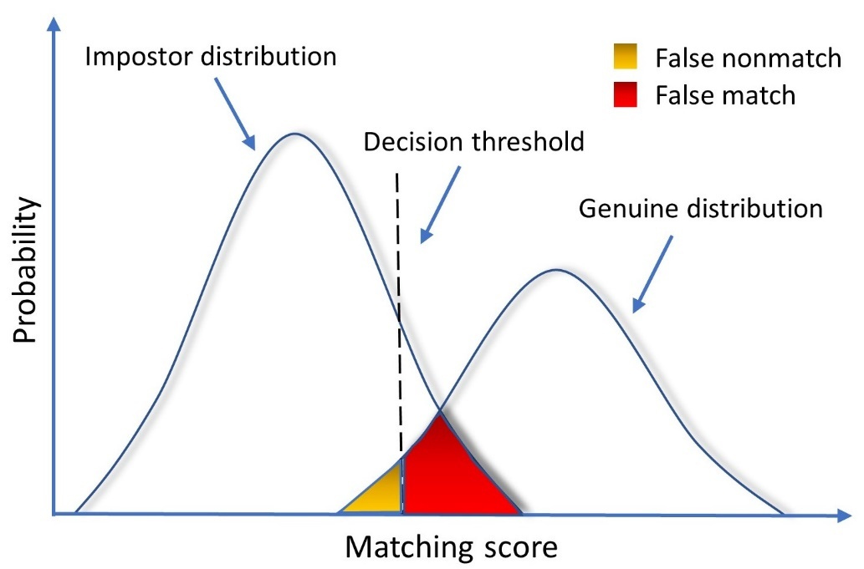
Figure 3. The false match and false non-match rates indicate the correlation between matching scores and class probabilities of impostor and genuine distributions.
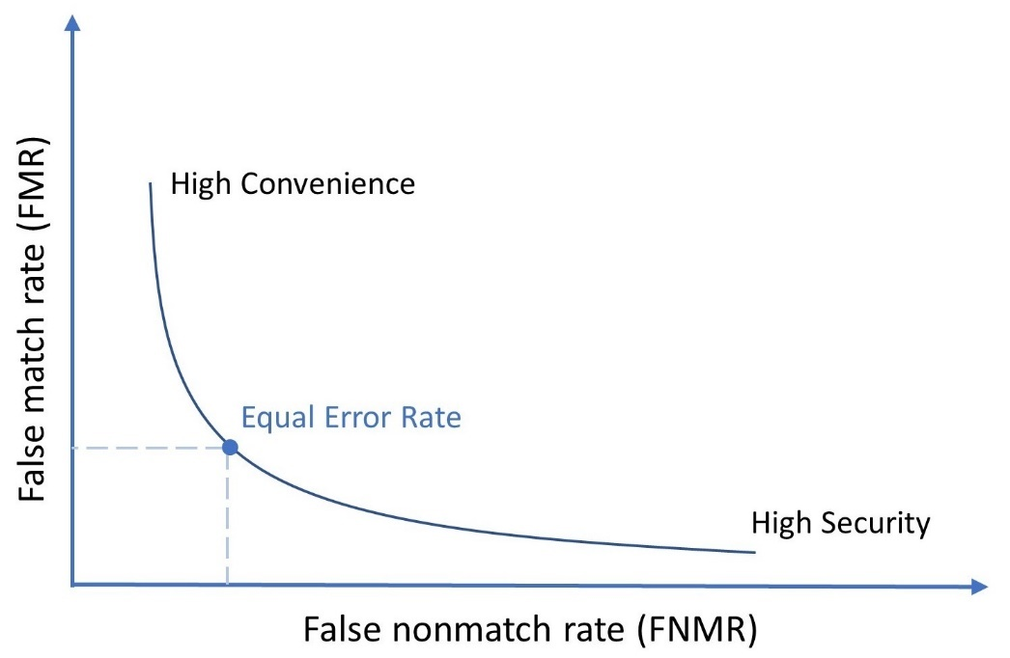
Figure 4. The false match rate (FMR) and false non-match rate (FNMR) trade-off represents the balance between security and convenience.

4.1.2 ECG Excels in Biometric Authentication
In this thesis, we delved into the realm of biometric identification practices with a specific focus on the utilization of electrocardiogram (ECG) signals. ECG, which measures the electrical activity of the heart, has emerged as a distinctive and promising input domain for biometric authentication.
One of the pioneering studies in the field was conducted by Biel et al. [44], who proposed an identification method using 12-lead ECG data. Their research demonstrated significant potential for ECG-based identification. However, it is important to note that the study had a limited number of samples, which limits the generalizability of their concept. Nevertheless, their findings laid the foundation for further exploration of ECG biometric recognition.
Building upon Biel et al.'s work, Odinaka et al. [45] conducted extensive research on ECG biometric recognition schemes. They investigated the effectiveness of earlier studies, particularly when the ECG data was obtained during the same session and captured subjects' rest or motion state. This line of research confirmed the viability of using ECG signals for biometric identification purposes, showcasing the potential of ECG as a reliable and unique biometric modality.
To provide a comprehensive analysis of ECG-based biometric authentication, Ingale et al. [46] published a detailed and comparative study on the subject. Their work not only synthesized the theoretical background of ECG biometrics but also shed light on recent advancements in the field. Their findings served as an important reference point for our own research, inspiring us to further explore the possibilities and challenges of ECG-based biometric identification.
In conclusion, the early studies by Biel et al. and subsequent research by Odinaka et al. and Ingale et al. have collectively contributed to the growing body of knowledge on ECG biometric authentication. These studies have highlighted the potential of ECG as a unique and reliable biometric modality, opening up new avenues for secure and convenient identification. By building upon these foundational works, we aim to further advance the field of ECG-based biometric identification and explore its practical applications in various domains.

4.1.3 Related Work
The utilization of ECG as a biometric modality has been explored since the early 2000s, demonstrating its potential in reliable identification.
The pioneering work by Biel et al. showcased impressive results in authentication using 12-lead ECG, highlighting the possibility of individual identification based on features extracted from a single lead. Inspired by this breakthrough, Shen et al. [47] conducted identity verification research using data streams from a single lead ECG device, incorporating a template-matching approach in the preprocessing stage. Their findings significantly influenced subsequent studies in the field.
Moving forward, Chan et al. [48] adopted a different approach by utilizing raw features of the ECG signals for biometric authentication. Their focus on extracting and analyzing the inherent characteristics of the ECG waveform contributed to the development of alternative methods.
In a distinct approach, Plataniotis et al. [49] introduced non-fiducial features in their study, incorporating additional attributes beyond traditional fiducial points. This novel perspective enhanced the richness of information used for ECG-based authentication.
With the emergence of data-centric strategies, researchers have turned their attention to data transformations to enhance the distinguishability of inputs. Among these methods, one of the earliest and influential techniques is piecewise linear regression (PLR), which is commonly employed in the feature extraction process [50, 51].
Feature extraction in ECG biometrics can be categorized into two branches: handcrafted and non-handcrafted. Fiducial features, along with PLR and autocorrelation [52, 53], fall under the handcrafted approach. While fiducial features may not enjoy the same popularity as other methods currently, they have been successfully utilized in combination with a classification algorithm like support vector machine (SVM), leading to noteworthy studies [54, 55].
In addition to fiducial features, handcrafted features can be obtained using techniques such as discrete cosine transform and wavelet transform, specifically designed for ECG biometric authentication. The field of handcrafted feature extraction offers diverse approaches. For instance, Kim et al. explored the application of Shannon entropy to transform raw ECG data into an evaluatable form using decision trees. However, their experiments lacked high accuracy, and important metrics such as false match rate (FMR) and false non-match rate (FNMR) were not provided.
In a distinctive research endeavor, Li et al. proposed the utilization of graph regularization non-negative matrix factorization and sparse representations for ECG biometrics, presenting an innovative approach that sets it apart from other studies.
These various methods and approaches in handcrafted feature extraction contribute to the ongoing advancements in ECG-based biometric authentication, expanding the range of possibilities for accurate and reliable identification.

4.2 Proposed Method for Biometric Authentication

4.3 Proposed Method for Time-Series Classification with Graph Neural Networks

5. IMPLEMENTATION ENVIRONMENT, RESULTS AND DISCUSSION

5.1 Environment Details

5.2 Results for Node Classification

5.3 Results for Biometric Authentication with VisGIN

6. CONCLUSION AND FUTURE DIRECTION

6.1 Conclusion

6.2 Prospective Future Direction

References

[1] | A. Hogan, E. Blomqvist, M. Cochez, C. D’amato, G. D. Melo, C. Gutierrez, S. Kirrane, J. E. L. Gayo, R. Navigli, S. Neumaier and associates, "Knowledge Graphs," ACM Comput. Surv., vol. 54, no. 4, 2021.
[2] | M. M. Bronstein, J. Bruna, Y. LeCun, A. Szlam and P. Vandergheynst, "Geometric Deep Learning: Going beyond Euclidean data," IEEE Signal Processing Magazine, vol. 34, no. 4, pp. 18-42, 2017.
[3] | Q. Xuan, J. Zhou, K. Qiu, Z. Chen, D. Xu, S. Zheng and X. Yang, "AvgNet: Adaptive Visibility Graph Neural Network and Its Application in Modulation Classification," IEEE Transactions on Network Science and Engineering, vol. 9, no. 3, pp. 1516-1526, 2022.
[4] | S. Wu, M. Liang, X. Wang and Q. Chen, "VGbel: An exploration of ensemble learning incorporating non-Euclidean structural representation for time series classification," Expert Systems with Applications, vol. 224, p. 119942, 2023.
[5] | Z. Wu, S. Pan, F. Chen, G. Long, C. Zhang and P. S. Yu, "A Comprehensive Survey on Graph Neural Networks," IEEE Transactions on Neural Networks and Learning Systems, vol. 32, no. 1, pp. 4-24, 2021.
[6] | E. Choi, Z. Xu, Y. Li, M. Dusenberry, G. Flores, E. Xue and A. Dai, "Learning the Graphical Structure of Electronic Health Records with Graph Convolutional Transformer," Proceedings of the AAAI Conference on Artificial Intelligence, vol. 34, no. 1, pp. 606-613, 2020.
[7] | T. Bian, X. Xiao, T. Xu, P. Zhao, W. Huang, Y. Rong and J. Huang, "Rumor Detection on Social Media with Bi-Directional Graph Convolutional Networks," Proceedings of the AAAI Conference on Artificial Intelligence, vol. 34, no. 1, pp. 549-556, 2020.
[8] | N. Park, A. Kan, X. L. Dong, T. Zhao and C. Faloutsos, "Estimating Node Importance in Knowledge Graphs Using Graph Neural Networks," in Proceedings of the 25th ACM SIGKDD International Conference on Knowledge Discovery & Data Mining, Anchorage, AK, USA, 2019.
[9] | Z. Cui, K. Henrickson, R. Ke and Y. Wang, "Traffic Graph Convolutional Recurrent Neural Network: A Deep Learning Framework for Network-Scale Traffic Learning and Forecasting," IEEE Transactions on Intelligent Transportation Systems, vol. 21, no. 11, pp. 4883-4894, 2020.
[10] | Y.-T. Lin, M.-T. Wu and K.-Y. Su, "Syntax-aware Natural Language Inference with Graph Matching Networks," in 2020 International Conference on Technologies and Applications of Artificial Intelligence (TAAI), Taipei, Taiwan, 2020.
[11] | P. Pradhyumna, G. P. Shreya and Mohana, "Graph Neural Network (GNN) in Image and Video Understanding Using Deep Learning for Computer Vision Applications," in 2021 Second International Conference on Electronics and Sustainable Communication Systems (ICESC), Coimbatore, India, 2021.
[12] | W. Hamilton, Z. Ying and J. Leskovec, "Inductive Representation Learning on Large Graphs," in Advances in Neural Information Processing Systems, Long Beach, CA, 2017.
[13] | J. Gasteiger, A. Bojchevski and S. Günnemann, Predict then Propagate: Graph Neural Networks meet Personalized PageRank, arXiv, 2022.
[14] | F. Wu, A. Souza, T. Zhang, C. Fifty, T. Yu and K. Weinberger, "Simplifying Graph Convolutional Networks," in Proceedings of the 36th International Conference on Machine Learning, Long Beach, CA, 2019.
[15] | P. Veličković, G. Cucurull, A. Casanova, A. Romero, P. Liò and Y. Bengio, "Graph Attention Networks," in International Conference on Learning Representations, Vancouver, BC, Canada, 2018.
[16] | P. Veličković, W. Fedus, W. L. Hamilton, P. Liò, Y. Bengio and R. D. Hjelm, Deep Graph Infomax, arXiv, 2018.
[17] | I. Benjamini and L. Lovász, "Harmonic and analytic functions on graphs," Journal of Geometry, vol. 76, no. 1, p. 3–15, 2003.
[18] | D. K. Duvenaud, D. Maclaurin, J. Iparraguirre, R. Bombarell, T. Hirzel, A. Aspuru-Guzik and R. P. Adams, "Convolutional networks on graphs for learning molecular fingerprints.," in Advances in Neural Information Processing Systems, Montreal, Canada, 2015.
[19] | M. Simonovsky and N. Komodakis, "Dynamic Edge-Conditioned Filters in Convolutional Neural Networks on Graphs," in 2017 IEEE Conference on Computer Vision and Pattern Recognition (CVPR), Honolulu, HI, USA, 2017.
[20] | D. J. Gilmer, S. S. Schoenholz, P. F. Riley, O. Vinyals and G. E. Dahl, "Neural Message Passing for Quantum Chemistry," in Proceedings of the 34th International Conference on Machine Learning, Long Beach, CA, 2017.
[21] | K. Xu, W. Hu, J. Leskovec and S. Jegelka, How powerful are graph neural networks?, arXiv, 2018.
[22] | J. Bruna, W. Zaremba, A. Szlam and Y. LeCun, Spectral networks and locally connected networks on graphs, arXiv, 2013.
[23] | X. Zhu, Z. Ghahramani and J. D. Lafferty, "Semi-supervised learning using Gaussian fields and harmonic functions," in Proceedings of the Twentieth International Conference on Machine Learning, Washington, DC, 2003.
[24] | A. Hagberg, D. S. Chult and P. J. Swart, "Exploring network structure, dynamics, and function using networkx," in Proceedings of the 7th Python in Science conference (SciPy 2008), Pasadena, CA, 2008.
[25] | L. He, C. T. Lu, J. Ma, J. Cao, L. Shen and P. S. Yu, "Joint community and structural hole spanner detection via harmonic modularity," in Proceedings of the 22nd ACM SIGKDD International Conference on Knowledge Discovery and Data Mining, San Francisco, CA, 2016.
[26] | W. W. Zachary, "An information flow model for conflict and fission in small groups," J. Anthropol. Res., vol. 33, p. 452–473, 1977.
[27] | J. Leskovec and A. Krevl, SNAP datasets: Stanford Large Network Dataset Collection, 2014.
[28] | A. Bharali, "An analysis of Email-Eu-Core network," Int. J. Sci. Res. Math. Stat. Sci., vol. 5, p. 100–104, 2018.
[29] | D. Grattarola and C. Alippi, "Graph neural networks in TensorFlow and Keras with Spektral," IEEE Comput. Intell. Mag., vol. 16, p. 99–106, 2021.
[30] | T. N. Kipf and M. Welling, Semi-supervised classification with graph convolutional networks, arXiv, 2016.
[31] | F. Scarselli, M. Gori, A. C. Tsoi, M. Hagenbuchner and M. G., "The graph neural network model," IEEE Trans. Neural Networks, vol. 20, pp. 61-80, 2009.
[32] | I. Kim, S. Han, S.-J. Park, J.-w. Baek, J. Shin, J.-J. Han and C. Choi, "DiscFace: Minimum Discrepancy Learning for Deep Face Recognition," in Computer Vision -- ACCV 2020, Kyoto, Japan, 2021.
[33] | M. Ahsan, M. A. Based, J. Haider and M. Kowalski, "An intelligent system for automatic fingerprint identification using feature fusion by Gabor filter and deep learning," Computers and Electrical Engineering, vol. 95, p. 107387, 2021.
[34] | A. Alzubaidi, S. Roy and J. Kalita, "A data reduction scheme for active authentication of legitimate smartphone owner using informative apps ranking," Digital Communications and Networks, vol. 5, no. 4, pp. 205-213, 2019.
[35] | S. Minaee and A. Abdolrashidi, DeepIris: Iris Recognition Using A Deep Learning Approach, arXiv, 2019.
[36] | M. Knoche, M. Elkadeem, S. Hörmann and G. Rigoll, "Octuplet Loss: Make Face Recognition Robust to Image Resolution," in 2023 IEEE 17th International Conference on Automatic Face and Gesture Recognition (FG), Hawaii, USA, 2023.
[37] | A. Kumar and H. Om, "An improved and secure multiserver authentication scheme based on biometrics and smartcard," Digital Communications and Networks, vol. 4, no. 1, pp. 27-38, 2018.
[38] | Minahil, M. F. Ayub, K. Mahmood, S. Kumari and A. K. Sangaiah, "Lightweight authentication protocol for e-health clouds in IoT-based applications through 5G technology," Digital Communications and Networks, vol. 7, no. 2, pp. 235-244, 2021.
[39] | Z. Zhang, H. Ning, F. Farha, J. Ding and K.-K. R. Choo, "Artificial intelligence in physiological characteristics recognition for internet of things authentication," Digital Communications and Networks, 2022.
[40] | G. Singh, G. Bhardwaj, S. V. Singh and V. Garg, "Biometric Identification System: Security and Privacy Concern," in Artificial Intelligence for a Sustainable Industry 4.0, Springer International Publishing, 2021, pp. 245--264.
[41] | I. u. haq, J. Wang, Y. Zhu and S. Maqbool, "An efficient hash-based authenticated key agreement scheme for multi-server architecture resilient to key compromise impersonation," Digital Communications and Networks, vol. 7, no. 1, pp. 140-150, 2021.
[42] | U. Uludag and A. K. Jain, "Attacks on biometric systems: a case study in fingerprints," in Security, Steganography, and Watermarking of Multimedia Contents VI, San Jose, CA, 2004.
[43] | Y. Zhang, C. Gao, S. Pan, Z. Li, Y. Xu and H. Qiu, "A Score-Level Fusion of Fingerprint Matching With Fingerprint Liveness Detection," IEEE Access, vol. 8, pp. 183391-183400, 2020.
[44] | L. Biel, O. Pettersson, L. Philipson and P. Wide, "ECG analysis: a new approach in human identification," IEEE Transactions on Instrumentation and Measurement, vol. 50, no. 3, pp. 808-812, 2001.
[45] | I. Odinaka, P. H. Lai, A. D. Kaplan, J. A. O'Sullivan, E. J. Sirevaag and J. W. Rohrbaugh, "ECG Biometric Recognition: A Comparative Analysis," IEEE Transactions on Information Forensics and Security, vol. 7, no. 6, pp. 1812-1824, 2012.
[46] | M. Ingale, R. Cordeiro, S. Thentu, Y. Park and N. Karimian, "ECG Biometric Authentication: A Comparative Analysis," IEEE Access, vol. 8, pp. 117853-117866, 2020.
[47] | T. W. Shen, W. J. Tompkins and Y. H. Hu, "One-lead ECG for identity verification," in Proceedings of the Second Joint 24th Annual Conference and the Annual Fall Meeting of the Biomedical Engineering Society] [Engineering in Medicine and Biology, Houston, TX, USA, 2002.
[48] | A. D. C. Chan, M. M. Hamdy, A. Badre and V. Badee, "Person Identification using Electrocardiograms," in 2006 Canadian Conference on Electrical and Computer Engineering, Ottawa, ON, Canada, 2006.
[49] | K. N. Plataniotis, D. Hatzinakos and J. K. M. Lee, "ECG Biometric Recognition Without Fiducial Detection," in 2006 Biometrics Symposium: Special Session on Research at the Biometric Consortium Conference, Baltimore, MD, USA, 2006.
[50] | S. I. Safie, J. J. Soraghan and L. Petropoulakis, "Electrocardiogram (ECG) Biometric Authentication Using Pulse Active Ratio (PAR)," IEEE Transactions on Information Forensics and Security, vol. 6, no. 4, pp. 1315-1322, 2011.
[51] | J. Shen, S.-D. Bao, L.-C. Yang and Y. Li, "The PLR-DTW method for ECG based biometric identification," in 2011 Annual International Conference of the IEEE Engineering in Medicine and Biology Society, Boston, MA, USA, 2011.
[52] | S. Wahabi, S. Pouryayevaliand, S. Hari and D. Hatzinakos, "On Evaluating ECG Biometric Systems: Session-Dependence and Body Posture," IEEE Transactions on Information Forensics and Security, vol. 9, no. 11, pp. 2002-2013, 2014.
[53] | M. Komeili, W. Louis, N. Armanfard and D. Hatzinakos, "Feature Selection for Nonstationary Data: Application to Human Recognition Using Medical Biometrics," IEEE Transactions on Cybernetics, vol. 48, no. 5, pp. 1446-1459, 2018.
[54] | H.-S. Choi, B. Lee and S. Yoon, "Biometric Authentication Using Noisy Electrocardiograms Acquired by Mobile Sensors," IEEE Access, vol. 4, pp. 1266-1273, 2016.
[55] | J. S. Paiva, D. Dias and J. P. S. Cunha, "Beat-ID: Towards a computationally low-cost single heartbeat biometric identity check system based on electrocardiogram wave morphology," PLOS ONE, vol. 12, no. 7, pp. 1-32, 2017.

Acknowledgements

Publications from the Thesis
Hacı İsmail Aslan, Hoon Ko, and Chang Choi. "Classification of vertices on social networks by multiple approaches.", Mathematical Biosciences and Engineering, 19 (12), 12146-12159, doi: 10.3934/mbe.2022565
Hacı İsmail Aslan and Choi, Chang, “VisGIN: Visibility Graph Neural Network on One-Dimensional Data for Biometric Authentication”. Available at SSRN: https://ssrn.com/abstract=4423327 or http://dx.doi.org/10.2139/ssrn.4423327

